Tab 1

Reducing Energy Costs Using Thermal Mass in Refrigerator

Isabel Price, Kalino Ruiz, Matthew Manuel, Brent Marin, Caleb Mok

Advisor/Instructor: Dr. Keith Yi, Technical Advisor: Sargon Ishaya

Me195a Senior Design Project I, Section 02

San José State University

Charles W. Davidson College of Engineering, Mechanical Engineering Department

12/12/2025

# Executive Summary

For this senior design project, the team is retrofitting a mini refrigerator with a passive cycle designed to save money through avoiding energy consumption during peak hours. The design premise follows a passive cooling system that fits into a preexisting mini refrigerator’s freezer compartment with a fan that blows air over an assembly of ice packs and heat sinks. This was optimized using a custom spreadsheet. The ice in the casings will freeze during the traditional active vapor compression refrigeration cycle. Then, the microcontroller will turn off the active cycle during peak hours and instead run only the passive cooling fan, which consumes less power while still maintaining the refrigeration chamber at a safe temperature of below 40°F.

From design calculations, the required ice volume is 109 cubic inches to meet the theoretical average grocery load of 51W for three hours. This load was used to select the heat sink and operating point with an expected channel velocity of 1.7 m/s and airflow of 85 CFM. Upon modification, the mini refrigerator’s electronics were successful in turning on the fan when temperature exceeds 40°F and off when the temperature drops below 37°F during the passive period. The annual load shifted from peak period is 29.7 kWh with a projected $12.93 based on a 5-8 pm time-of-use residential utility rate from PG&E. Compared to the annual cost for operation without the retrofit, $184.26 dollars, this is a 7% reduction in electricity cost per year. Though the project is successful in achieving electricity cost savings and electronics operation, the temperature does not meet specifications 20% of the time and the velocity profile through the face of the heat sink is not evenly distributed.

# Acknowledgements

Firstly, the team would like to acknowledge the support received and give a huge thanks to the project advisor, Dr. Keith Yi. Dr. Yi has been responsive and provided helpful feedback on design decisions and calculations throughout the semester. His feedback has been invaluable.

Secondly, the team would like to thank Desmond Cheung for his time, support, and resources in regards to the ice casing construction. This project would not have been successful without him.

Next, the team would like to thank Professor Hussameddine Kabbani. Professor Kabbani offered his expertise and advice at the early stages of the project, which ultimately led to the selection of this smart refrigerator project.

Finally, the team would like to thank Professor Sargon Ishaya for his advice in the final stages of design and calculations, as well as the offer to provide additional input as a technical advisor next semester. As a professor of the HVAC course at SJSU, Professor Ishaya’s knowledge and expertise in refrigeration systems are greatly valued for this project.

# Table of Contents

Executive Summary 2

Acknowledgements 3

Table of Contents 4

List of Figures 6

List of Tables 8

**Chapter 1 - Project Introduction and Background** 9

Section 1.1- Background and Motivation 9

Section 1.2- Project Objectives 10

Section 1.3- Design Specifications 10

Section 1.4- Customer Needs Summary 12

Section 1.5 - Project Significance and Uniqueness 13

Section 1.6 - Society and Technology related to your project 13

Section 1.7 - Team Work Plan 13

Section 1.8 - Gantt Chart 14

**Chapter 2: Literature Review and Theoretical Background Related to Refrigeration** 15

Section 2.1 - Theoretical Background and Engineering Principles 15

Section 2.2 - Literature Review of Existing Solutions 18

Section 2.3 - Technical Challenges 20

**Chapter 3 - Smart Refrigerator Design Requirements and Concept Development** 21

Section 3.1 - Design Requirements 21

Section 3.2 - Concept Development and Selections 21

Section 3.2.1 - Prime design concept 21

Section 3.2.2: Alternate concepts considered 24

Section 3.2.3: Concept Selection 25

Section 3.3 - Detailed Design and Analysis 27

Section 3.3.1 – Material and Component Selection 28

Section 3.3.2 – Budget and Cost Analysis 29

Section 3.3.3 – Design Calculations 30

Section 3.3.4 - Detailed Drawings 36

**Chapter 4 - Refrigerator’s Circuitry, Microcontroller, and System Interface** 38

Section 4.1 – Circuitry Development, interface, and programming codes 38

Section 4.2 - Summary of Microcontroller and Electronic Features 42

Section 4.3 - Block Diagram 45

Section 4.4 - System integration and data acquisition 45

**Chapter 5 - Prototyping and Fabrication of the Smart Refrigerator** 46

Section 5.1 - Materials and Fabrication Processes 46

Section 5.2 - Assembly Procedures 47

Section 5.3 - Fabrication Challenges 49

Section 5.4 - Economic Analysis and Societal Benefits 50

Section 5.5 - Design to Meet Safety, Environmental, and Engineering Codes 50

Section 5.6 - Final System Overview 50

**Chapter 6 - Testing and Result Analyses of Refrigerator’s Operation** 51

Section 6.1 - Testing Plan and Methodology 51

Section 6.2 - Data Analysis and Results 52

**Chapter 7 - Conclusions and Future Work** 54

Section 7.1 - Evaluation of Design and Calculations 55

Section 7.2 - Comparison of Experimental Results to Design Specifications 55

Section 7.3 - Reflection on Team Collaboration 55

Section 7.4 - Cost Analysis Conclusion 56

Section 7.5 - Limitations 56

Section 7.6 - Potential Improvements and Future Development 57

References 58

‌Appendix A: Detailed Calculations 59

Appendix B: Detailed Simulation Results and Computer Programs 63

Appendix C: Programming Codes and Schematics 64

Appendix D: Excerpts from Datasheets of Components 70

Appendix E: Customer Needs Survey 71

Appendix F: Power and Temperature Data Logger Data and Plots 71

# List of Figures

Figure 1: Trend in Electricity Cost in the United States 9

Figure 2: Residential Time of Use Rate Plan from PG&E 10

Figure 3 - Air Temperatures at Evaporator and Condenser 11

Figure 4 - Instantaneous Load vs Time of Day 12

Figure 5 - Path of Airflow for Passive Cooling Cycle 17

Figure 6 - CCRC Passive Cycle Prototype Schematic (Garber-Slaght, 2013) 19

Figure 7 - Trane Collaboration Peak/Off-Peak Cooling System 20

Figure 8 - Final design - Control Panel Layout 21

Figure 9 - Final Design - Heat Sink and Ice Assembly 22

Figure 10 - Final Design - Freezer layout: Fan Placement, Vanes, and Airflow Direction 23

Figure 11 - Final Design - Mini Refrigerator Interior Layout 23

Figure 13 - Fin/Block Placement 24

Figure 14 - Control Panel Placement 25

Figure 15 - Freezer Design Concepts 25

Figure 16 - Simulation Results Plotted for Chosen Heat Sink 33

Figure 17 - System and Fan Pressure Curve 34

Figure 18 - Heat sink and plastic wall drawing 36

Figure 19 - Control Panel Top Drawing 37

Figure 21 - AC to DC Converter Drawing 37

Figure 22 - Full Refrigerator Circuit Diagram 38

Figure 23 - Breadboard Prototype Circuit 39

Figure 24 - Circuit Diagram of Control Panel Protoboard 40

Figure 25 - Code for Hour, Minute, and Clockset Buttons 41

Figure 26 - Main Trigger Function Code 41

Figure 27 - Back of Control Panel, Top Layer 42

Figure 28 - Side Profile of Control Panel 42

Figure 29 - Female header pins soldered beneath the ESP32 43

Figure 30 - Custom Male connection for Female IDC connector 43

Figure 31 - Block Diagram 45

Figure 32 - Electronics integrated at the rear of the refrigerator 46

Figure 33: Control Panel Casing and Buttons with Labels 47

Figure 34: Flex Seal on the Inside of a Plate and Welded Heat Sink Before CNC 48

Figure 35: Gaps in Heatsink 49

Figure 36: Before and After Shaving the Fan 50

Figure 37 Velocity measurements with hotwire anemometer. 51

Figure 38 - Velocity profile of heat sink face without vane install. 52

Figure 39 - Instantaneous power and temperature recorded on December 5th, 2025 54

Figure 40 - Loss Coefficient due to Expansion and Contraction 59

Figure 41 - Loss Coefficient due to Bends 60

Figure 42 - Fan Performance Sheet 70

Figure 43: Temperature and Power plot from 11/29 to 12/07 74

Figure 44 - Temperature and Power Plot for December 2nd, 2025 75

## 

# 

# List of Tables

Table 1 - Customer Needs Survey 13

Table 2 - Gantt Chart 14

Table 3 - Thermal Entry Length. 16

Table 4 - Pugh Matrix for Heat Transfer Shapes 27

Table 7 - Example Output Table from Heat Sink Simulation Spreadsheet 31

Table 8 - Simulation Results for Chosen Heat Sink 32

Table 9 - Pressure Drop Calculations 35

Table 7 - Nusselt Number Depending on Flow Condition 59

Table 10 - Nusselt Number for Constant Surface Temperature given Width a and Height b 60

Table 11 - Water, Ice, and Air Properties 60

Table 12 - Shell Surface Area and Heat Transfer Through Walls Calculation 61

Table 13 - Inputs and Preliminary Calculations for Heat Transfer Simulation Spreadsheet 62

Table 12 - Customer Needs Survey 71

Table 13 - Energy Calculation Summary Table for Energy Analysis 71

### 

# 

# Chapter 1 - Project Introduction and Background

# Section 1.1- Background and Motivation

Energy production is highly variable, depending not only on natural/renewable resources present in a country, but also on global trade. War, economic recession, and trade disputes can all affect a country’s ability to procure energy. Making it one of the first things to increase in price when things go awry on the global stage. For instance, from February 2022 to August 2022, average electricity costs in America rose from $0.15/kWh to $0.164/kWh due to the war in Ukraine, significantly outpacing already high inflation. The trend in electricity cost in the United States is shown below in Figure 1 as provided by the Federal Reserve Bank of St. Louis.

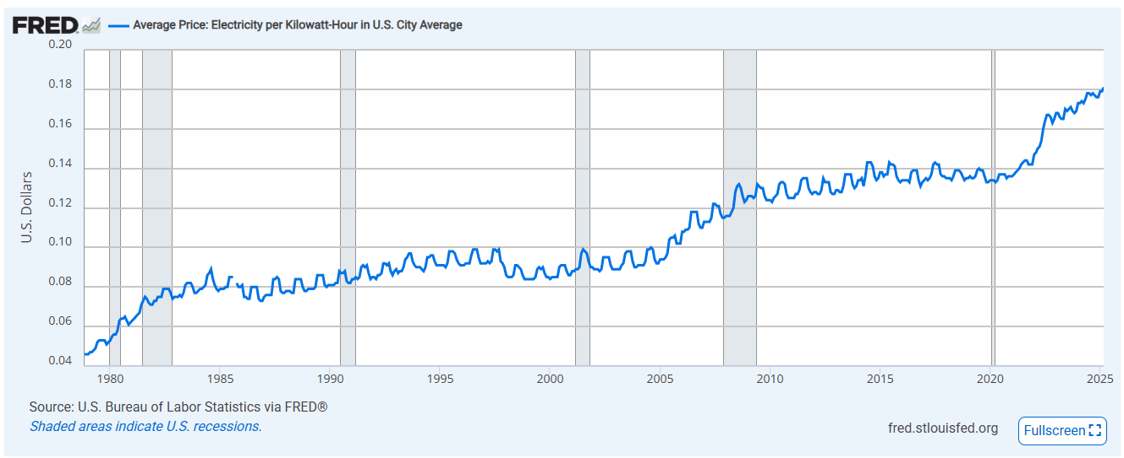

## Figure 1: Trend in Electricity Cost in the United States

California has the second-highest energy rates in the US, only behind Hawaii. Monthly utility bills have outpaced inflation by $15-20 since 2015 ([McGhee, 2025](https://www.ppic.org/blog/a-closer-look-at-californias-surging-electricity-rates/#:~:text=California%20has%20long%20had%20high,over%2080%25%20higher%20last%20year.)). While there are several reasons for this, the result is the same: energy is expensive, and this expense weighs heavily on those worse off. When compounded with the high cost of housing and food due to inflation, lower-income Americans choose to miss out on a meal or two if it means they can keep the lights and heat on (Luna, 2023). While not as much of an issue in California as little heating is required, the high cost of housing means that any compounded energy cost can be especially damaging.

Refrigerators are non-negligible energy end-users. Refrigerators generally use 5% or more of daily household energy usage, and run 24/7 (EIA, 2018). The electricity cost of refrigerators usually costs between $50 and $150 a year. This cost is rather significant for an essential item that almost every household needs, so this project aims to create a fridge that will ideally offer energy cost savings. To achieve energy cost savings, the refrigerator uses load shifting from peak to off-peak with the use of thermal mass and a secondary passive cooling system. The cost of electricity is much higher during peak hours when there is a higher demand for electricity. This can be seen in the PG&E time-of-use rate schedule for residential households in Figure 2.

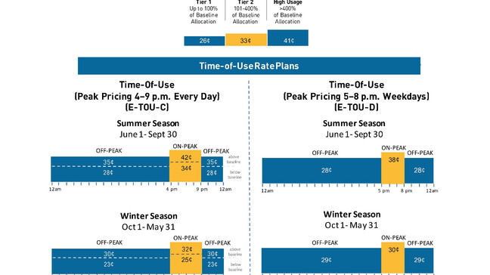

## Figure 2: Residential Time of Use Rate Plan from PG&E

# Section 1.2- Project Objectives

This project had two main objectives. The first objective was to keep the refrigerator at a safe temperature for food storage. After doing some background research, the team concluded that refrigerator temperature should be maintained below 40°F. The second objective was to save money through avoiding energy usage during peak hours of the chosen example rate schedule: 5 PM to 8 PM. Money will be saved through utilizing a passive cycle that will operate during the peak hours, while the traditional active refrigeration cycle will be turned off. This technology differs from prior work as there are no currently available refrigerators that utilize thermal mass as a method of shifting load from peak to off-peak hours to save the consumer money.

The main principles of the project revolve around thermal mass conservation and refrigeration cycles. The passive cycle will consist of casings of ice with heat sinks attached, the ice will freeze while the active cycle runs. Once peak hours hit, a fan will turn on and blow air over the ice casings to keep the contents of the fridge below 40°F. The plan is to take an existing minifridge and build the passive cycle using as many original components as possible.

# Section 1.3- Design Specifications

*Space Constraints*

The defined dimensions of the mini refrigerator restricts the maximum size of the heat sink assembly and fan. The inner dimensions of the existing refrigerator are 29”x15.5”x14”. Freezer space that can be used for the thermal mass/heat sink is about 4.75”x14.5”x13”.

*Temperature constraints*

The most important temperature constraint in the design is the temperature set point inside the refrigeration chamber. This must be maintained within adequate refrigeration temperatures of less than 40°F to ensure safety.

*Active Refrigeration Cycle*

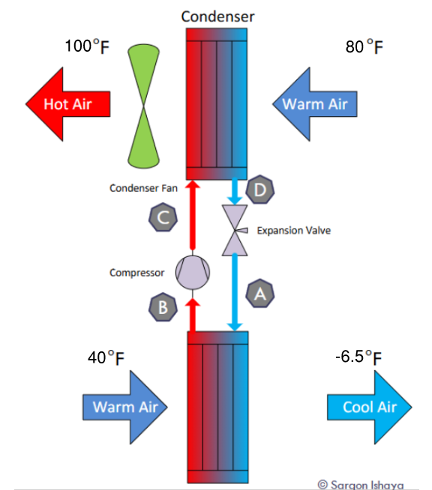

## Figure 3 - Air Temperatures at Evaporator and Condenser

Figure 3 depicts a typical vapor compression refrigeration cycle within a refrigerator. The ambient temperature of a typical home on a hot day in San Jose falls within the range of 70-80°F. This means that the entering temperature into the condenser will be 80°F maximum. Using estimations from other refrigeration models, the leaving air temperature of the condenser is expected to be 100°F. The temperature of air entering the evaporator coil will be approximately 40°F, a few degrees warmer than the temperature setpoint. Finally, the typical air temperature leaving the evaporator will be approximately -6.5°F.

*Simulated Grocery Load*

A simulation of the load on the refrigerator during typical usage acts as a basis for the passive cooling sizing. Two methods of heat entering the refrigerator are considered in this model including the constant heat transfer through the walls and the irregular addition of groceries. Another source of heat transfer that is not considered is the heat that enters when the refrigerator door opens and mixes the air.

The temperature difference between the refrigerated chamber at 37°F and the ambient room temperature at 70°F creates the constant load of 49W. The detailed calculations can be found below in Table 12 in Appendix A.

The addition of groceries to the refrigerator is simulated as bottles of room-temperature water that are added throughout the day. Figure 4 demonstrates the instantaneous load in kW on the refrigerator in response to the bottles of water vs the time of day. The average instantaneous load during the passive cooling period from 5 pm to 8 pm is 51 W.

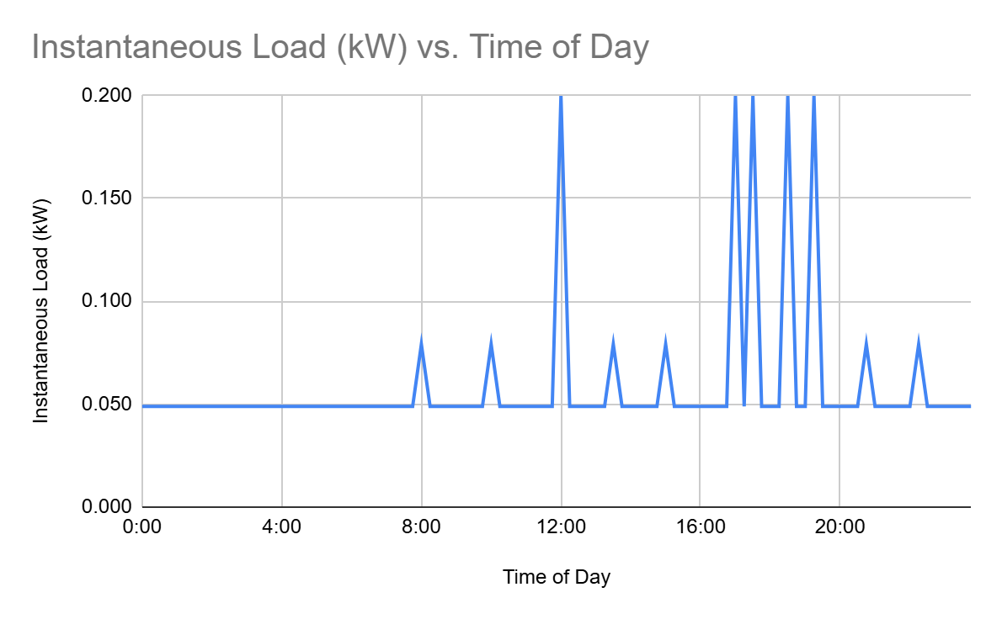

## Figure 4 - Instantaneous Load vs Time of Day

# 

# Section 1.4- Customer Needs Summary

| **Customer Need** | | | **Weighted average from survey** | **Team member's Subjective weight** |
| --- | --- | --- | --- | --- |
| **User friendly** | | | | |
| Easy to use | | | 7.0 | 7.8 |
| Easy user interface | | | 7.0 | 7.4 |
| Easy to clean | | | 8.4 | 8.4 |
| Easy to organize | | | 8.0 | 6.6 |
| Easy to move | | | 4.6 | 4.2 |
| **Cost of Operation** | | | | |
| Cost of Product | | | 6.4 | 9.2 |
| Energy Usage | | | 8.2 | 8.6 |
| Durability | | | 8.8 | 7.0 |
| **Features** | | | | |
| Water Dispenser | | | 6.6 | 2.6 |
| Interior Storage Space | | | 9.6 | 9.4 |
| Ice Maker (for user ice) | | | 7.0 | 2.8 |
| Temperature Adjustment | | | 6.4 | 4.2 |
| Aesthetics | | | 6.0 | 5.0 |
| **Other** | | | | |
| Noise level | | | 7.2 | 6.4 |

### Table 1 - Customer Needs Survey

A customer needs survey was conducted to determine the priorities of both the customer and the engineering team. From the survey, it was determined that ease of use, ease of organization, durability, and storage space are most important to prospective customers. These priorities were considered in the design process. Though there was success in prioritizing ease of use, ease of organization, and durability, the storage space within the freezer chamber was lost due to the addition of the heat sink assembly.

# Section 1.5 - Project Significance and Uniqueness

This project combines two common refrigeration techniques together to create energy cost savings for the consumer. Passive cooling is often not utilized in tandem with active cooling, especially in current refrigerators. Most refrigerators currently run at full power during peak rate hours, while a hybrid system may be able to offset a large amount of use during those peak hours.

# Section 1.6 - Society and Technology related to your project

Successful implementation of this project will provide energy cost savings for the user. Common users of mini fridges are students and other low-income residents that do not require or cannot afford a larger fridge. Even small energy cost savings can make a large difference for these residents. This project also explores the technological advantages of hybrid refrigeration systems, potentially opening the door for further research and larger-scale testing.

# Section 1.7 - Team Work Plan

The group manager is Isabel Price, and the communications director is Kalino Ruiz. These two roles are administrative, with the team lead responsible for overall cohesion while the communications director focuses on meeting minutes and occasional progress reports. As for technical roles, there are leads for each specification, but all members help others if they require assistance or if the task is large enough. Isabel Price is the heat transfer and electronics lead, responsible for the bulk of initial theoretical calculations as well as planning and implementation of the electronics components. Throughout the project Isabel successfully performed the initial heat transfer calculations to select the fan and heat sink, chose the electronic components, installed them in the refrigerator, soldered the control panel protoboard, and analyzed the energy and temperature data from testing. Caleb Mok is the fabrication lead, primarily responsible not only for creating the necessary parts for completing this project but also for coordinating BOM progress and part procurement. Caleb cut the heat sinks and aluminum plates to size, assembled the heat sink and ice layers and ensured that they were all successfully sealed. Brent Marin is the refrigeration lead, who was primarily responsible for the refrigeration aspects of the project as well as the investigation of the airflow including the return vent. Kalino Ruiz is the CAD/design lead, responsible for converting specifications required by the theoretical calculations into a design that can be fabricated or refined by other members. Kalino designed and 3D printed the ice casing layers, control panel interface, the fan safety cover, and the relay mounting board. Matthew Manuel is the coding lead, responsible for the development of the code in Arduino IDE. Matthew worked with the prototype electronics board to develop the code to meet the refrigerator’s specifications and create a user friendly control panel operation.

# Section 1.8 - Gantt Chart

### Table 2 - [Gantt Chart](https://docs.google.com/spreadsheets/d/1WM0p94JmNZS4vIe-lfO75XZXaNq4TFAwoFLuRLCb8F0/edit?usp=sharing)

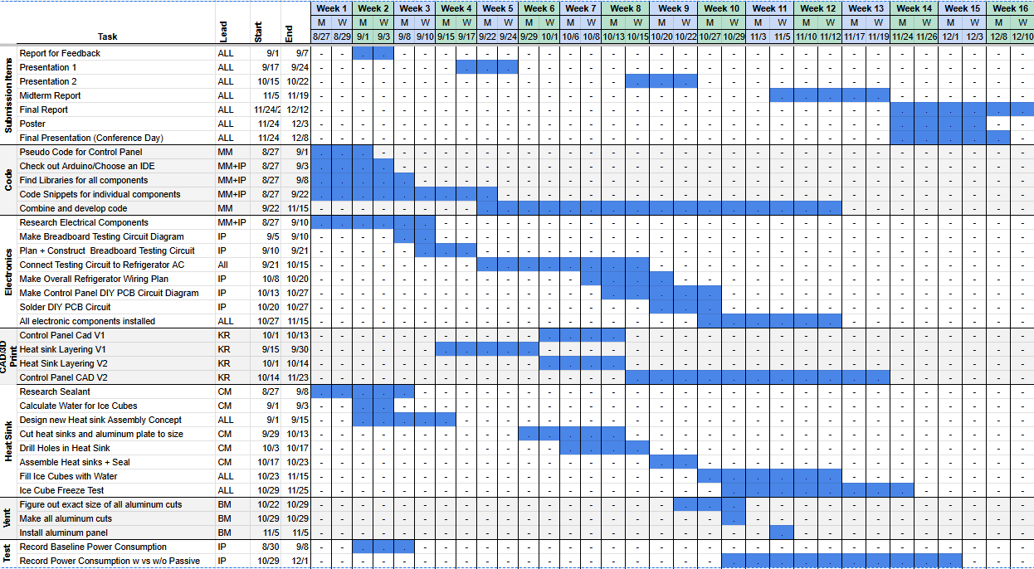

### 

The gantt chart is shown above and is the team’s collective schedule for the Fall 2025 semester. Initials of assigned leads for different assignments are included for organization. Each assignment was completed on time, however some tasks were not required for project completion such as the aluminum cuts into the back. Some assignments were also iterated on throughout the semester such as the code and fabrication process.

# 

# Chapter 2: Literature Review and Theoretical Background Related to Refrigeration

# Section 2.1 - Theoretical Background and Engineering Principles

This project relates to concepts from thermodynamics, heat transfer, fluid dynamics, and mechatronics. Thermodynamics and heat transfer concepts describe the conservation and transfer of heat throughout the refrigeration system. The active loop of the refrigerator operates with a vapor compression cycle in which refrigerant changes in pressure, temperature, and as a result phase as it travels through the refrigerator and moves the heat from inside the freezer chamber to the exhaust into the ambient room.

Like all other commercially available refrigerators, this Smart Refrigerator will utilize the vapor compression cycle during the active cooling mode. The mini refrigerator that’s undergoing retrofitting does not have an evaporator fan. Instead, the air is cooled through the means of natural convection, which occurs due to the density differences caused by the difference in temperature between the air. As the air close to the evaporator coils cools, it will sink lower into the refrigerator, while the warm air will rise until it is near the evaporator coil to reduce its temperature as well.

*Thermodynamics*

There are two thermodynamics calculations involved with this senior design project: the energy that must be removed to decrease the temperature of water, and the energy that is used to melt ice. The energy removed from a solid or incompressible liquid can be found using the following equation, where m is the mass (kg), cp is the specific heat capacity at constant pressure (kJ/kgᐧ°C), and $ΔT$ is the change in temperature (°C).

Eq 1. $Q = m c_{p}ΔT$

The energy required to change the phase of a substance is much greater than the energy required to change its temperature. The equation to describe the phase change from water to ice is as follows, where L is the latent heat of fusion (kJ/kg)

Eq 2. $Q = m L$

Eq 2. Q $= \frac{ΔT}{R_{Total}}$

̇

The passive cooling refrigeration loop during peak hours utilizes forced convection as a fan creates a pressure differential. This forces the air to blow through the ice block and heat sink assembly at a velocity. Both heat transfer and fluid mechanics concepts must be applied to analyze how effectively the passive cooling system delivers cool air to the refrigeration chamber with the purpose of maintaining the temperature less than 37°F.

*Heat transfer*

The first step in determining the heat transfer for forced convection for internal flow is to calculate the volumetric flow per each fin, air velocity, and Reynolds number as per Equation 1 below, where V is air velocity (m/s), Dh is the calculated hydraulic diameter (m), and 𝜈 is kinematic viscosity (m2/s)

Eq 3. Reynolds number $Re =\frac{VD_{h}}{ν}$

Next, the flow condition and entry length were determined. For internal flow, the flow can be considered laminar for a Reynolds number less than 2300. Flow is typically considered transitional between 2300 and 4000 and turbulent at greater than 4000. Depending on whether the flow was considered laminar or transitional/turbulent, the entry length was calculated with the respective equation, shown in Table 3, where Pr is the Prandtl number.

### Table 3 - Thermal Entry Length.

| Laminar | Turbulent (or Transitional) |
| --- | --- |
| $L_{t, laminar}=0.05PrD_{h}Re$ | $L_{t, turbulent}=10D_{h}$ |

If the entry length is greater than the depth of the heat sink, the flow is developing, while if it’s less than, the flow is considered fully developed. Based on the laminar/turbulent and developed/developing flow conditions, the corresponding equation for Nusselt Number is chosen as shown in Table 7, found below in Appendix A. The heat transfer coefficient can be found using the following relationship, where h is the heat transfer coefficient (W/m2 ᐧ°C) and k is the thermal conductivity (W/mᐧ°C).

Eq 4. $Nu = \frac{hD}{k}$

To account for the temperature differential across the fins, the fin efficiency was calculated and included in the provided heat transfer with the following equations, where P is the fin perimeter (m), AC is the cross-sectional area per fin channel (m2), and L is the length of the heat sink that the air is blowing across (m).

Eq 5. Fin efficiency: $η = \frac{tanh(mL)}{mL}$ Eq 6. $m=\sqrt{\frac{hP}{kA_{c}}}$

The provided heat transfer is calculated using Logarithmic mean temperature difference and the convection heat transfer equation below, where As is the total surface area of including all of the fins (m2). Finally, this provided heat transfer can be compared to the required heat transfer determined from the grocery load simulation, 51 W.

Eq 7. $ΔT_{LMTD }= \frac{{ΔT}_{1}- {ΔT}_{2}}{ln \left(\frac{{ΔT}_{1}}{{ΔT}_{2}}\right)}$ where ${ΔT}_{1}=T_{inlet}- T_{base}$ and ${ΔT}_{2}=T_{outlet}-T_{base}$

Eq 8. Q̇ = $ηhA_{s}ΔT_{LMTD }$

*Fluid Mechanics*

As air flows through a channel, there’s pressure loss due to both the friction between the air and the surface as well as the turbulence that occurs in transitions, including turns, enlargement, and contraction. The path that the air must take in the mini refrigerator is shown below in Figure 5. In the application, the pressure loss due to transitions will be several magnitudes larger than the pressure loss due to friction, so it only considers the transitions in the calculations.

## 

## Figure 5 - Path of Airflow for Passive Cooling Cycle

The pressure drop due to transitions can be found with the following equation. Where K is the loss coefficient that is specific to a given transition and found using Figures 40 and 41 found below in Appendix A.

Eq. 9 $ΔP =K\frac{ρV^{2}}{2}$

# Section 2.2 - Literature Review of Existing Solutions

Using a passive cycle and thermal mass is a simple method of cooling, as they are essentially ice chests. Ice chests were common up until the 1930s and relied heavily on good insulation and an ice supply to keep food cold and safe. Ice chests were successful at keeping things cold, but were eventually replaced by refrigerators with the modern vapor compression cycle. Despite this, after thorough research, no examples of people attempting to retrofit or create a refrigerator of any size with both an active and a passive cycle, were found.

However, there are examples of the theory of thermal mass being applied. In 2013, the Cold Climate Research Center (CCRC) developed a refrigerator in Alaska that had fins that were affixed to the condenser coils and ducted outside to take advantage of the freezing cold air and wind, and cool the refrigerant down as depicted in Figure 6. It also had the traditional vapor compression cycle, but the CCRC was able to control how much it ran, and for the sake of testing, they had the compressor run at a minimal setting. Attached below is a figure of the prototype. This model proved to be effective during the winter months, consuming only 6.3 kWh with the passive model compared to 36.1 kWh over the same period of time with the active refrigeration cycle (Garber-Slaght, 2013).

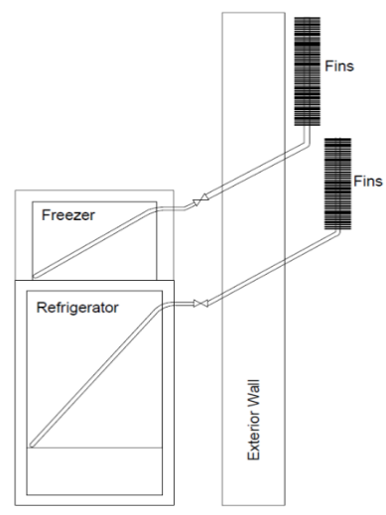

## Figure 6 - CCRC Passive Cycle Prototype Schematic (Garber-Slaght, 2013)

Another example of thermal mass being applied is a collaboration project between the HVAC equipment manufacturers Trane, Natgun, Ice Energy, and Calmac to develop a large-scale on/off peak cooling system for a building. The building’s chillers would chill water for the cooling coils, but also send some of the chilled water into a large tank. The large tank would be filled up before peak electricity rates hit. Once the peak hours hit, the chillers would turn off, and a valve would close, cutting the chillers off from the loop, so that the large tank supplies the cooling coils with cold water, then cycles back to the tank. A comprehensive diagram is listed below in Figure 7.

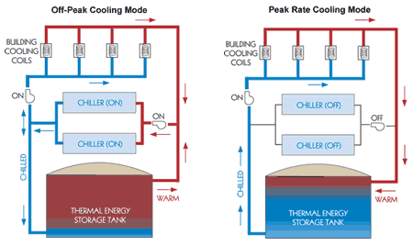

## Figure 7 - Trane Collaboration Peak/Off-Peak Cooling System

This system is effective at reducing carbon dioxide emissions, energy consumption, and saving its clients money. According to an article from Trane’s website, the 11 Madison Avenue building in New York has saved 1.4 million pounds of Carbon Dioxide emissions and a 25% reduction in central plant kilowatt-hour consumption since its installation 10 years ago. In addition to this, the building had a 10% reduction in tenant energy costs and saved more than “$730,000 annual building energy- and operating-cost savings, while reducing the strain on the electric grid” (Suitable Transformation…, 2024). Trane plans on continuing to develop this peak/off-peak cooling system and install it in more buildings.

# Section 2.3 - Technical Challenges

While several advantages of passive cooling solutions have been explored above, there are key drawbacks that must also be addressed. Passive cooling that utilizes the environment requires very cold average weather to be effective, as shown by Garber-Slaght. In California, where average temperature hovers anywhere from 50°F-80°F, other solutions such as chilled water tanks or PCMs must be utilized. Thermal storage tanks are the most commonly implemented passive cooling system, however, often the thermal mass required takes a large physical space to accommodate. Passive systems may also not be able to fully accommodate high loads on a system, which creates the danger of the system not keeping temperature within specification.

# 

# Chapter 3 - Smart Refrigerator Design Requirements and Concept Development

# Section 3.1 - Design Requirements

Codes and standards that are relevant to this project include control of internal temperatures to prevent foodborne illnesses. The United States Food and Drug Administration, or FDA, has made it clear that foods which require cold preservation should be stored at temperatures under 40°F. This is because bacteria thrives at temperatures higher than this, and is the reason this refrigerator should maintain an internal temperature of under 40°F.

Another concern is the type of refrigeration that can be used. The refrigerant that the mini fridge uses is R-134a. It is still on the market despite being under regulatory consideration for its high global warming potential. With this in mind, the final product will meet the current code if the proper resources are available.On another note, refrigerators must be made so they can be opened from the inside. This is an understandable safety regulation, especially for those who have kids who can fit inside mini fridges. The manufactured mini fridge will already be designed with this in mind.

# Section 3.2 - Concept Development and Selections

# Section 3.2.1 - Prime design concept

*Control Panel*

The final design of the Smart Refrigerator is set to maintain an internal temperature of below 40°F. The control panel is located on the front of the fridge. Two LED lights on the control panel indicate the state of the refrigerator: Passive or Active. The panel has 5 buttons in total. Temperature allows for the user to check the current internal temperature of the refrigerator. For the testing code, hour and minute allow for the user to set how long passive cooling will last for. Clockset begins the cycle, and end immediately switches the fridge over to the active cycle. Figure 8 demonstrates the layout of the control panel.

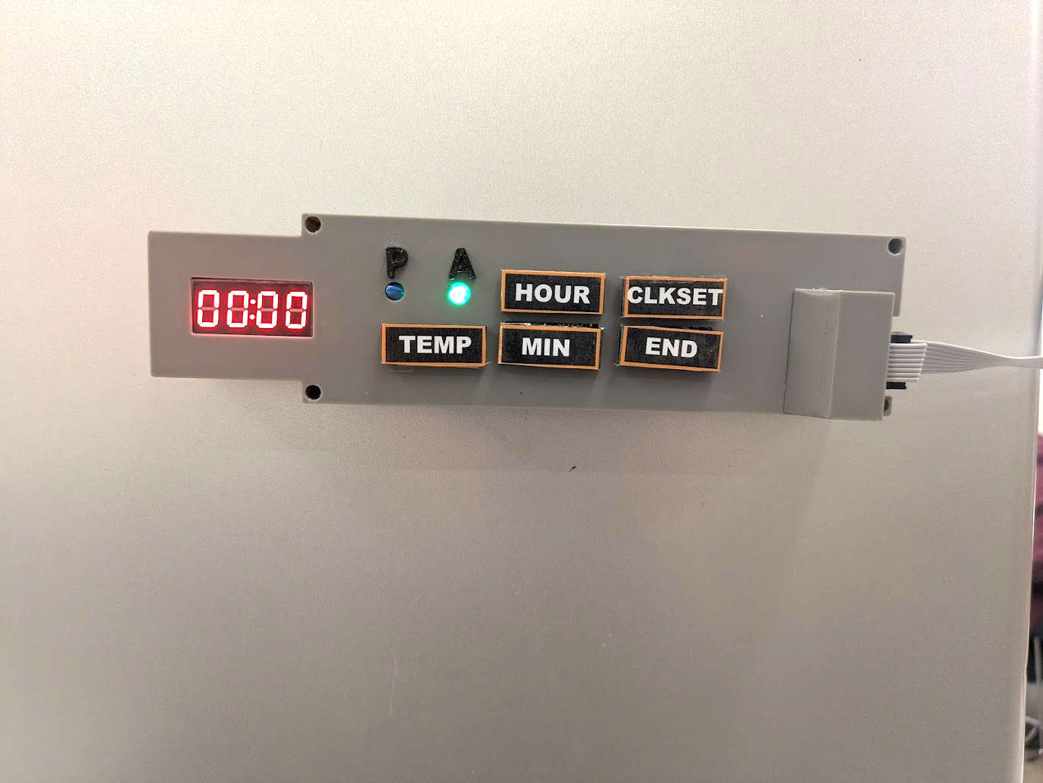

## Figure 8 - Final design - Control Panel Layout

*Heat sink and ice layers*

Figure 9 depicts the heat sink assembly. Four layers of heat sinks enhance the heat transfer. Three layers of ice maintain the base surface temperature of each heat sink at 0°C. Each layer of ice is encased by 3D printed ABS walls around the sides.

|  |
| --- |

## Figure 9 - Final Design - Heat Sink and Ice Assembly

*Freezer compartment layout*

The layout of the freezer compartment is designed such that the airflow enters through the central rear and disperses throughout the heat sink assembly. Figure 10 depicts the location of the fan, heat sink assembly, and hole near fan which is where input air is gathered.

|  |
| --- |

## Figure 10 - Final Design - Freezer layout: Fan Placement, Vanes, and Airflow Direction

## 

*Refrigerator interior and return duct*

The mini refrigerator’s storage layout consists of one removable shelf that rests above a single removable drawer. There are slots for up to 3 removable shelves. The refrigerator’s interior layout freezer compartment can be seen below in Figure 11.

.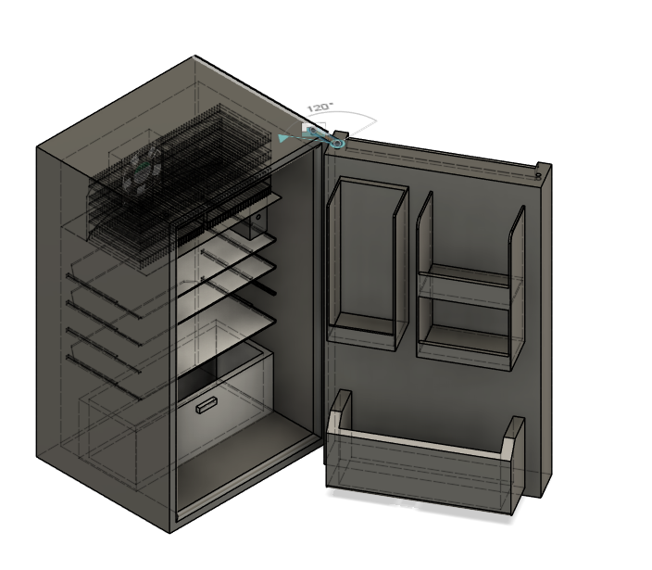

## Figure 11 - Final Design - Mini Refrigerator Interior Layout

## 

# Section 3.2.2: Alternate concepts considered

Alternative design concepts were divided into design sections of heat transfer, shelf placement, control panel, and fan placement, since these were the areas that had the most variation.

Of the five fin and ice block designs, the chosen prototype was selected based on maximum heat transfer ability. Designs 1 and 2 have the fins and ice block placed in the freezer compartment of the refrigerator, the difference being that Design 1 uses one large slab of ice while Design 2 uses several thin layers of ice. Designs 3 through 5 have the freezer compartment located in the back of the fridge. Design 3 is similar to Design 2, using layers of thin ice, with the main difference being the vertical placement of the fins. Designs 4 and 5 are similar in design, having the fins horizontal instead with Design 4 having rectangular tubes while Design 5 has cylindrical tubes.

### 

| Design 1 | Design 2 | Design 3 | Design 4 | Design 5 |
| --- | --- | --- | --- | --- |
|  |  |  |  |  |

## Figure 13 - Fin/Block Placement

For the control panel, a simple setup displayed the refrigerator cycle status, as well as toggle it on or off. Three different placements with a display on the front door, above the fridge door, or inside the fridge were considered, as shown in Figure 14. Also, temperature adjustment or display controls were deliberated in making the layout for the panel.

| Design 1 | Design 2 | Design 3 |
| --- | --- | --- |
|  |  |  |

## Figure 14 - Control Panel Placement

Figure 15 below displays three possible layouts for the return duct, fan, and ice casing assembly. The design parameters in consideration tried to maximize the size of the ice casing assembly, as well as allow efficient airflow and limit static pressure for the fan. In these diagrams, the red rectangle represents the return duct opening, and the blue arrows are the projected airflow through the ice block and fins. These design concepts are all based on Design 2 from above in Figure 13 - Fin/Block Placement.

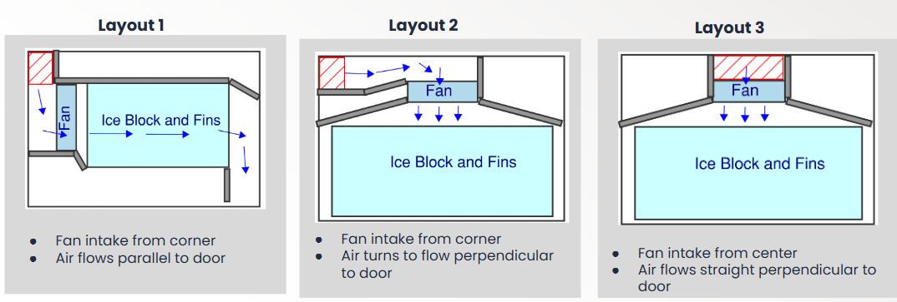

## Figure 15 - Freezer Design Concepts

# Section 3.2.3: Concept Selection

The design selection process came down to two metrics: cost to manufacture and adequate cooling. A Pugh chart, listed in Table 1, lists the pros and cons of each ice casing design. The criteria evaluated for each possible fin configuration were based on their ice freezing rate, fin surface area, manufacturability, use of space, and static pressure. After going through the Pugh chart, as well as performing the calculations for fan CFM, ice volume, and fin surface area in Section 3.2, it was clear that design 2 was the best option. Several different heat sink and ice layer layouts were analyzed to find the best option.

### 

### 

### Table 4 - Pugh Matrix for Heat Transfer Shapes

| **Criteria** | **Baseline/**  **Datum** | **Design 1** | **Design 2** | **Design 3** | **Design 4** | **Design 5** |
| --- | --- | --- | --- | --- | --- | --- |
| Ice freezing rate | 0 | 0 | +1 | -1 | +1 | -1 |
| Fin Surface Area | 0 | -1 | +1 | +1 | +1 | 0 |
| Manufacturability | 0 | +1 | +1 | +1 | 0 | -1 |
| Efficient Use of Space | 0 | +1 | +1 | +1 | 0 | 0 |
| Airflow Pattern/Static Pressure | 0 | +1 | +1 | +1 | -1 | -1 |
| Total |  | 2 | 5 | 4 | 1 | -3 |
| Rank |  | 3rd | 1st | 2nd | 4th | 5th |

For deciding the control panel location and interface, a team discussion occurred to decide what format would be easy to use, easy to program, and easy to manufacture. The customers' needs survey showed that temperature adjustment is low on priority, so the control panel and code should be as simple as possible.

Detailed calculations and a heat transfer spreadsheet simulation were used to choose the specific heat sink and determine the amount of ice required in the heat sink and ice assembly. The pressure drop for the system curve for the fan selection was chosen to be able to model what CFM is needed for the ice casing assembly. The heat sink and pressure drop calculations that justify the chosen design are explained in detail below in Section 3.3

The concept selection for fabrication was based on the team's experience and confidence in different manufacturing processes, what equipment was accessible, the cost to fabricate and manufacture each component, and how effective each component needs to be. Some of the group members have access to 3D printers, which helped with fabrication. One group member has experience with MIG welding, as well as access to a friend’s welder. As a group, each manufacturing process was ranked based on overall confidence, as well as possible performance. Some of the manufacturing processes evaluated were welding, 3D printing, brazing, glueing, tacking, screwing/nailing, CNCing, and plasma cutting.

# Section 3.3 - Detailed Design and Analysis

# Section 3.3.1 – Material and Component Selection

For the design the team started out with a mini fridge one of the team members had on hand. After deliberation and research, the team opted to keep the freezer compartment the same despite losing potential cooling ability by having a larger ice casing assembly and more room for the fan. The size of the ice casing assembly and how much air passes directly impacts the project's cooling ability. The evaporator coil was not cut for space primarily because the refrigerant inside the mini fridge would have to be drained and recharged. This requires expensive special equipment, as well as a certification from the state, as R134A refrigerant is harmful to the atmosphere. With the freezer compartment unmodified, adjustments were made to dimensions of the ice casing assembly as mentioned prior and seen in Figure 8.

For the design, calculations were done on the total amount of surface area of the ice casing assembly. There were four banks of heat sinks, all the same dimensions, so calculations were straightforward. Total surface area on the heat sinks was 1.34 m^2 which can be seen below in Table 5. No structural simulations were performed for the ice casings as they are not bearing any load. When it came to the construction of the ice casing assembly, aluminum plates and heat sinks were most promising. For the price, aluminum offered the best heat transfer abilities. Copper is also very good at transferring heat but it was not within the budget.

Table 5: Ice Casing Surface Area Table

| Length and Depth of Fin | |
| --- | --- |
| Length of block (in) | 6 |
| Depth of block (in) | 15.748 |
| Length of block (m) | 0.15 |
| Depth of block (m) | 0.40 |
| Area of block (m^2) | 0.061 |
| **Fin Parameters** | |
| Layers of ice | 3 |
| Height of fins (in) | 0.669 |
| Fin thickness (in) | 0.043 |
| Fin spacing (in) | 0.246 |
| Height of fins (m) | 0.017 |
| Fin thickness (m) | 0.0011 |
| Fin spacing (m) | 0.006 |
| Number of fins | 218 |
| a/b (spacing/height) | 0.4 |
| Cross sectional area PER FIN (m^2) | 0.000106 |
| Channel Perimeter PER FIN (m) | 0.040 |
| Hydraulic diameter (m) | 0.0106 |
| Total surface area (m^2) | 1.34 |

# Section 3.3.2 – Budget and Cost Analysis

Table 6 - Bill of Materials

| **Link** | **Item** | **Vendor** | **Qty** | **Unit Cost** | **Estimated Shipping + tax** | **Total Per Vendor** |
| --- | --- | --- | --- | --- | --- | --- |
| [Link](https://www.amazon.com/BOJACK-DS18B20-Temperature-Stainless-Waterproof/dp/B09NVFJYPS/ref=sr_1_1?crid=3S6TQVDOPXQM5&dib=eyJ2IjoiMSJ9.70OYroGThH_uuUI2iTvLq78NRZASO883SXzPr62pz2pTsj9vTaqd0d9KKgZGl-K8NxxjgRM4z1TyTeqREo6td-d5WgqVA5J5aK8Dbfu7EuKaxtuTQUgden1_8lgnj5heEGYdr-iMpnrPj30L8RHu6-sYhkry6eV8kFvpF6_wRJYoGW8S7xj-wip2cfZMF_Ljew9i5kQPR1rz_n-wAXTwKtS3DB83uJKTA-PLvzsuZLonBpOP27yvOn289-yiO8f3btI9qWyFO8T5iuBUPJqMybebgs6PDPnzGvCYGed366A.wiFyS-q5FnVYgl_kzch9dIK4ohxg6WXdOdtpJD5xt1k&dib_tag=se&keywords=ds18b20%2Bsensor&qid=1758678055&s=industrial&sprefix=ds18b20%2Bsensor%2Cindustrial%2C149&sr=1-1&th=1) | Temperature Sensor (2 Pack) | Amazon | 1 | $5.99 | $3.54 | $38.89 |
| [Link](https://www.amazon.com/dp/B00LW15A4W?ref=ppx_pop_mob_ap_share&th=1) | One Channel Relays (2 Pack) | Amazon | 1 | $7.39 |
| [Link](https://www.amazon.com/dp/B093GW6SZ1?ref=ppx_pop_mob_ap_share) | AC to DC Converter (5 Pack) | Amazon | 1 | $9.99 |
| [Link](https://www.amazon.com/dp/B0FGJ7N5JG?ref=cm_sw_r_cso_cp_apan_dp_KKCCRM6T6205KC28W2H2&ref_=cm_sw_r_cso_cp_apan_dp_KKCCRM6T6205KC28W2H2&social_share=cm_sw_r_cso_cp_apan_dp_KKCCRM6T6205KC28W2H2&titleSource=true&th=1) | 3 Way Wire Splitters (10 Pack) | Amazon | 1 | $5.99 |
| [Link](https://www.amazon.com/dp/B0F4P352BB?ref=ppx_pop_mob_ap_share) | Resistors | Amazon | 1 | $5.99 |
| [Link](https://www.metalsdepot.com/aluminum-products/aluminum-sheet?product=381) | Aluminum Sheets | Metals Depot | 2 | $45.40 | $19.58 | $110.38 |
| [Link](https://heatsinkonline.com/products/7874-wide-heatsink-64as?variant=42105916653730&country=US&currency=USD&utm_medium=product_sync&utm_source=google&utm_content=sag_organic&utm_campaign=sag_organic&utm_campaign=gs-2022-07-05&utm_source=google&utm_medium=smart_campaign&gad_source=4&gbraid=0AAAAABmrCYdmSs6RRO8d2MZDT69-jNeqJ&gclid=CjwKCAjwq7fABhB2EiwAwk-YbNJNHDVNKmhC6NEKsVn3wKhq0ggWOAc9W3ACV31yxpUNhxtY-Ju1OxoCGtAQAvD_BwE) | Heat Sink | Heat Sink Online | 8 | $11.39 | $21.42 | $112.54 |
| [Link](https://www.jameco.com/z/SP100A-1123XBT-GN-Sunon-120mm-115-VAC-60Hz-Ball-Bearing-Fan-240mA-20W-117-CFM_102884.html) | Fan | JameCo Electronics | 1 | $13.95 | $12.50 | $30.40 |
| [Link](https://www.jameco.com/z/TM1637-JVP-Jameco-ValuePro-TM1637-4-Bits-Digital-Red-LED-Display-Module-for-Arduino-7-Segment-0-36-4-Digit-Clock-Anode-Serial-Driver-Board_2325423.html?CID=GOOG&utm_source=google&utm_medium=ppc&utm_campaign=&utm_term=&utm_content=&gad_source=4&gad_campaignid=17336645193&gbraid=0AAAAADoyMrdTfjL0XWHlsPpaIKEPx7iFT&gclid=Cj0KCQjwlMfABhCWARIsADGXdy-5ZPRjeSekmAhkRNRcc-6NoqRiyiN0gZbNljShqVxzSGMeHSO1yvcaApfOEALw_wcB) | 4 Digit Display | JameCo Electronics | 1 | $3.95 |
| Already owned | Buttons | Already owned | 5 | - | - | - |
| Already owned | Breadboard | Already owned | 1 | - | - | - |
| Already owned | Buck Converter | Already owned | 1 | - | - | - |
| [Link](https://www.homedepot.com/p/Loctite-Silicone-Waterproof-Multipurpose-Adhesive-Sealant-2-7-oz-Clear-Tube-908570/303769575) | SIlicone Waterproof Sealant | Home Depot | 1 | $6.28 | $0.63 | $6.91 |
| [Link](https://www.amazon.com/Antrader-2-54mm-Sockets-Female-Connector/dp/B0BVHMTY5S/ref=sr_1_3?crid=1608T3WQ9JH1W&dib=eyJ2IjoiMSJ9.UELVZ9en0cN9lks_ORM_cFnkBReWEcYQWYJTO_6Kd5D0ipRzpNdmPy7UMrzErKDNdDdUds3jpnY6dd5UqpWS7IzDkHWOA8ebSa3F9z01KQM3KwGm3Kf7pEhjfvvXmERRbKDWZxkV6qfKGJqOyCjW3tx-SUbkvFF6a4WpWlOT0drs3ag5UJ395-ebQzFlD7G9t_3n4QW_nKPRywzUqq1ZLdGKQ_PJkaHg5Kze0pMYUe99llmOCFwwfcVoTzyL2nbCYdFo4uId7lHlIHnD15SJY5KX9u-CVfFmTPzJgXcSuuU.QVG94HyeFZT4nmuLStIZimuDL8S6E25k6n4WX9TReq8&dib_tag=se&keywords=Flat%2BRibbon%2BCable%2B2.54mm%2BPitch%2B8%2Bpin%2Bfemale%2Bidc%2Bsingle%2Brow&qid=1760397657&s=industrial&sprefix=flat%2Bribbon%2Bcable%2B2.54mm%2Bpitch%2B8%2Bpin%2Bfemale%2Bidc%2Bsingle%2Brow%2Cindustrial%2C115&sr=1-3&th=1) | IDC Female Cable Connector | Amazon | 1 | $5.99 | $0.00 | $27.66 |
| [Link](https://www.amazon.com/Antrader-Ribbon-Cable-2-54mm-Connectors/dp/B07P77YRB2/ref=pd_bxgy_d_sccl_1/134-2577932-9484742?pd_rd_w=0cif6&content-id=amzn1.sym.de9a1315-b9df-4c24-863c-7afcb2e4cc0a&pf_rd_p=de9a1315-b9df-4c24-863c-7afcb2e4cc0a&pf_rd_r=E2MM69KQTE3N5XCA6H8P&pd_rd_wg=GcTcH&pd_rd_r=5ab76144-6932-4aa8-9794-1a32619b262f&pd_rd_i=B07P77YRB2&th=1) | Ribbon Cable | Amazon | 1 | $8.49 |

In the table above is the BOM with all of the components the team purchased for the construction of the project. There is nothing frivolous, but the highest quality components were selected at reasonable prices. Selections were based on the exact ice volume and fin surface area to maximize the amount of cooling, while occupying the least amount of internal volume. The full calculations are listed in Appendix A. There were cheaper materials available for certain components, such as 3D printing the ice casings or return duct. However, PLA filaments do not conduct heat well, especially for the fin casings. It is imperative that the maximum heat transfer possible occurs, so for this reason, some of the components will be constructed with aluminum. It is known that copper is the best at conducting heat, but copper casings or heat sinks were unrealistic within the budget and fabrication experience.

If the final design were to go into production, the cost per unit would go up. The primary reason is that one of the group members already had a mini fridge on hand. If units were to go into production, more mini fridges would need to be acquired, driving the cost per unit up. However, outside of acquiring the fridge, the rest of the costs would go down. The biggest costs in this project, outside of the fridge, are the aluminum heat sinks and sheet metal. First and foremost, shipping the aluminum costs quite a lot. For mass production, ordering sheetmetal in bulk would save on shipping. Another way costs would go down would be by utilizing sheet metal material. Only one unit is being built and extra sheet aluminum was purchased to guarantee there would be enough. As more units are produced, the sheet aluminum will be used more efficiently, saving money. The same principle applies to the aluminum heat sinks. Fabrication costs would go down per unit, but the overall price per unit would go up to account for acquiring mini fridges.

# Section 3.3.3 – Design Calculations

*Ice Block Calculation*

The total volume of ice required can be calculated based on the sum of the energy lost during the passive cooling period and ice properties using the heat equation for change of phase, Equation 2. Using the sum of the load during the passive cooling period from the load simulation, 545 kJ, the volume of ice can be calculated as follows.

$Q = m L$

$m = \frac{Q}{L} = \frac{545 kJ}{334 \frac{kJ}{kg}} =1.63 kg$

$V = \frac{m}{ρ} =\frac{1.63 kg}{917 \frac{kg}{m^{3}}}=0.0018 m^{3} =109 {in}^{3}$

*Heat sink heat transfer selection spreadsheet*

The most important specification of the Smart Refrigerator is that it is able to properly regulate the temperature of the storage chamber, such that the food doesn't spoil. The standard for refrigeration of food is between 35-40°F. The chosen target temperature range was between 37°F and 40°F, which is reflected in the simulated grocery load shown in Figure 4 of Section 1.3. The average load during the passive period, 51 W, is the target heat transfer rate that ensures that the refrigerator is able to maintain refrigeration and uphold this standard. Though this average load is used in the calculations, the passive system will be responding to the instantaneous load by controlling the speed of the fan.

To simulate the provided heat transfer for various heat sinks and air flow rates, a tool was created in Google Sheets that takes inputs for the heat sink fin spacing, thickness, and height as well as the length and width of the ice block configuration and the number of layers. The spreadsheet uses these inputs to calculate the actual heat transfer that occurs at a given air volumetric flow rate and compare it to the target heat transfer rate, 51 W. This allows the fin spacing, thickness, and height that can deliver the best heat transfer rate. Afterwards, the spreadsheet could determine how many layers of ice were required for a reasonable air flow rate and resulting pressure drop that a small fan could provide and overcome. An example output table of the spreadsheet can be found below in Table 7. All properties of air, water, ice, and aluminum used in the calculations can be found below in Table 9 in Appendix A.

### Table 7 - Example Output Table from Heat Sink Simulation Spreadsheet

| **volumetric flow (CFM)** | **20** | **30** | **50** | **55** | **60** | **70** |
| --- | --- | --- | --- | --- | --- | --- |
| V_dotTotal (m^3/s) | 0.00944 | 0.01416 | 0.02360 | 0.02596 | 0.02832 | 0.03304 |
| Mdot Total (kg/s) | 0.01215 | 0.01822 | 0.03037 | 0.03340 | 0.03644 | 0.04251 |
| V_dotPer fin (m^3/s) | 0.0000433 | 0.0000650 | 0.0001083 | 0.0001191 | 0.0001299 | 0.0001516 |
| MdotPer fin (kg/s) | 0.000056 | 0.000084 | 0.000139 | 0.000153 | 0.000167 | 0.000195 |
| Vair (m/s) | 0.408 | 0.612 | 1.020 | 1.122 | 1.224 | 1.427 |
| Re | 295 | 442 | 737 | 811 | 885 | 1032 |
| Flow | L | L | L | L | L | L |
| Entry Length | 0.156 | 0.233 | 0.389 | 0.428 | 0.467 | 0.545 |
| Developed? | N | N | N | N | N | N |
| Nu | 4.42 | 4.74 | 5.30 | 5.43 | 5.55 | 5.79 |
| h (W/m^2C) | 10.30 | 11.04 | 12.34 | 12.64 | 12.93 | 13.49 |
| m | 4.06 | 4.20 | 4.44 | 4.50 | 4.55 | 4.64 |
| fin efficiency | 88.94% | 88.26% | 87.08% | 86.82% | 86.57% | 86.08% |
| Toutlet (C) | 1.2 | 1.6 | 2.1 | 2.1 | 2.2 | 2.3 |
| (Tbase-Tin) | 5.04 | 5.04 | 5.04 | 5.04 | 5.04 | 5.04 |
| (Tout - Tsurf) | 1.1 | 1.5 | 2.0 | 2.1 | 2.2 | 2.3 |
| Delta T LMTD | 2.6 | 3.0 | 3.3 | 3.4 | 3.4 | 3.5 |
| Qfin, actual (W) | 31.9 | 38.5 | 47.4 | 49.2 | 50.8 | 53.9 |
| Qdot diff | -18.60 | -12.02 | -3.11 | -1.33 | 0.33 | 3.38 |

After the tool was created, the heat sink parameters for various heat sink options that were previously researched determined the minimum average air flow rate required for increasing layers of ice. This information was then put into tables for each heat sink in addition to the total height of the heat sink and ice block assembly, as well as the total cost. An example of the table and resulting plot is shown below in Table 8 and Figure 16, respectively. This allowed the team to compare heat sinks side by side with all the necessary criteria for a final decision.

### Table 8 - Simulation Results for Chosen Heat Sink

| **Layers of Ice** | **CFM** | **Total Height (in)** | **Total Cost** |
| --- | --- | --- | --- |
| 1 | 102 | 2.57 | $39.60 |
| 2 | 100 | 4.36 | $59.40 |
| 3 | 60 | 6.15 | $79.20 |
| 4 | 45 | 7.94 | $99.00 |
| 5 | 34 | 9.72 | $118.80 |

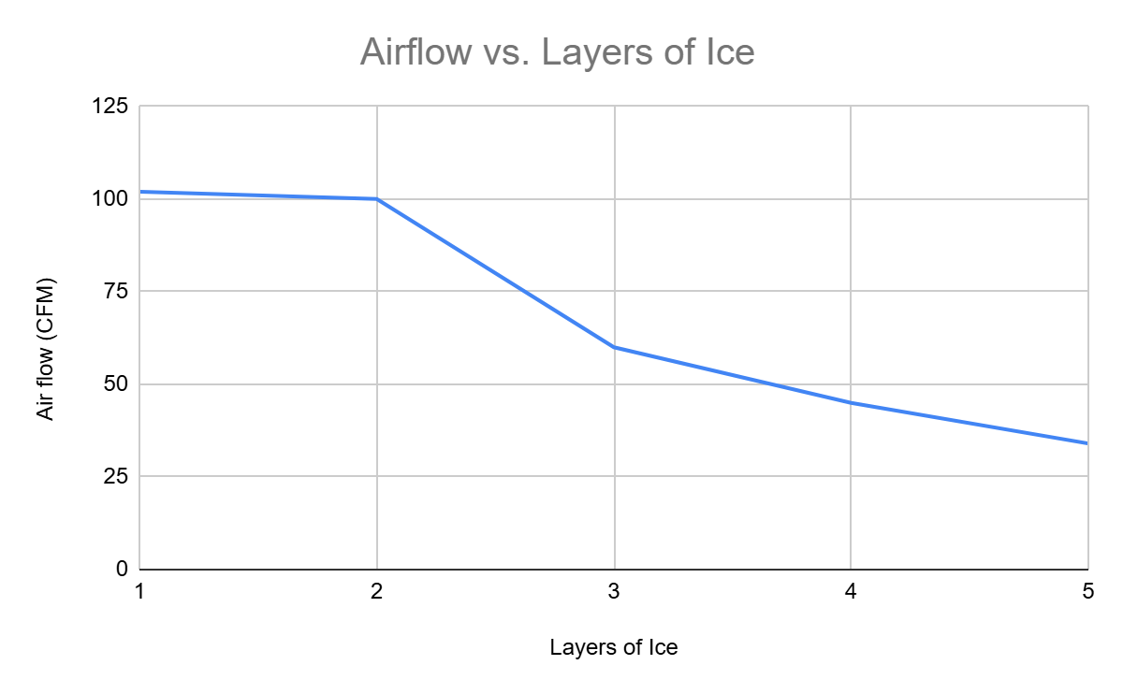

## Figure 16 - Simulation Results Plotted for Chosen Heat Sink

When compared to six different heat sinks that varied in fin spacing and height, the heat sink that had the optimal heat transfer and fit within the freezer compartment was chosen. Three layers of ice were required with the chosen heat sink to obtain a reasonable airflow rate.

*Pressure drop calculations and fan selection*

Before selecting the fan, the pressure drop at various air flow rates was calculated to create a system curve shown below in Table 9 and Figure 17. Research was done to find fans that had a maximum airflow rate about twice as large as the calculated average airflow. This would allow the passive system to respond to larger instantaneous loads and prevent the refrigerated space from exceeding the acceptable temperature range. The fan’s power consumption and size were the most important considerations. After choosing the fan that best met these criteria, the provided fan curve shown in Appendix D was plotted against the system curve to ensure that the fan was able to overcome the pressure drop it would encounter. Since the fan curve intersects the fan curve at a greater airflow than the minimum average airflow calculated previously, the fan will be adequate. The expected operating point of the system is 85 CFM at 0.15 inches of water column static pressure.

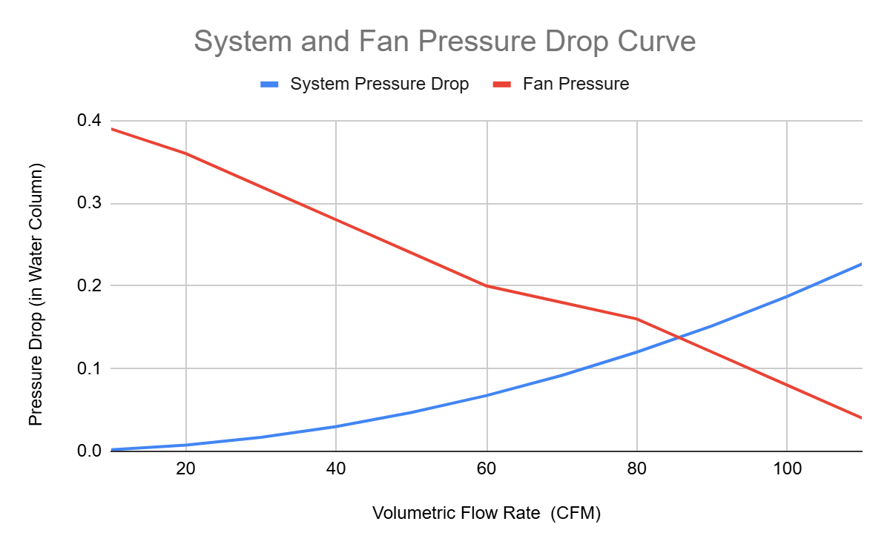

## Figure 17 - System and Fan Pressure Curve

### Table 9 - Pressure Drop Calculations

| **Pressure Drop Due to Transitions Calculations** | | | | | | | |
| --- | --- | --- | --- | --- | --- | --- | --- |
| Description | Percent of total cfm | Assumed cross area (in^2) | Velocity at each point (fpm) | Transition Type | D/D or A/A | Loss coefficient | Pressure Drop (in water) |
| Into Ice + fins | 100% | 0.400 | 1 | Straight | 0.0002 | 0.5 | 0.01 |
| Leaving Ice + fins | 100% | 0.400 | 1 | sudden expansion | 0.01 | 0.6 | 0.01 |
| 90 deg Turn | 100% | 28 | 566 | 90 deg sharp elbow | -- | 1.1 | 0.02 |
| 2 in x 14 in gap | 100% | 28 | 566 | sudden expansion | 0.14 | 0.65 | 0.01 |
| 2 in x 14 in gap | 75% | 28 | 566 | sudden expansion | 0.14 | 0.65 | 0.01 |
| 2 in x 14 in gap | 50% | 28 | 566 | sudden expansion | 0.14 | 0.65 | 0.01 |
| Into Drawer? | 25% | 28 | 566 | sudden expansion | 0.14 | 0.65 | 0.00 |
| Return vent | 100% | 18 | 880 | Return Grille | -- | 0.7 | 0.04 |
| Turn | 100% | 18 | 880 | 90 deg sharp elbow x 2 | -- | 1.1 | 0.06 |
| Turn | 100% | 18 | 880 | 90 deg sharp elbow | -- | 1.1 | 0.06 |
| Input airflow (CFM) | | | 110 | Pressure Drop Total Given Input CFM | | | 0.23 |

# Section 3.3.4 - Detailed Drawings

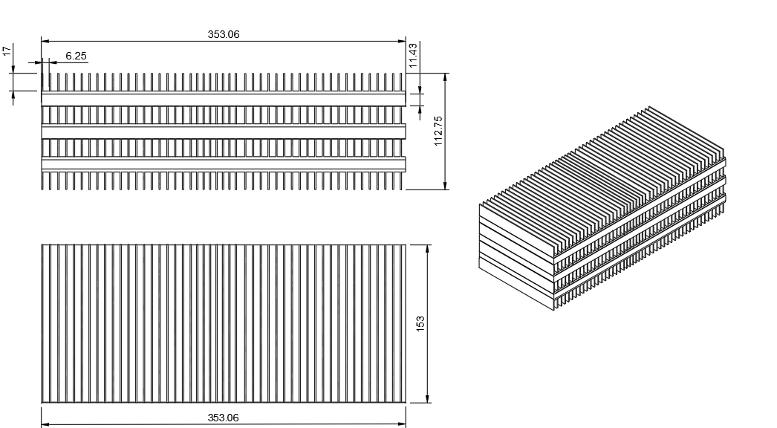

## Figure 18 - Heat sink and plastic wall drawing

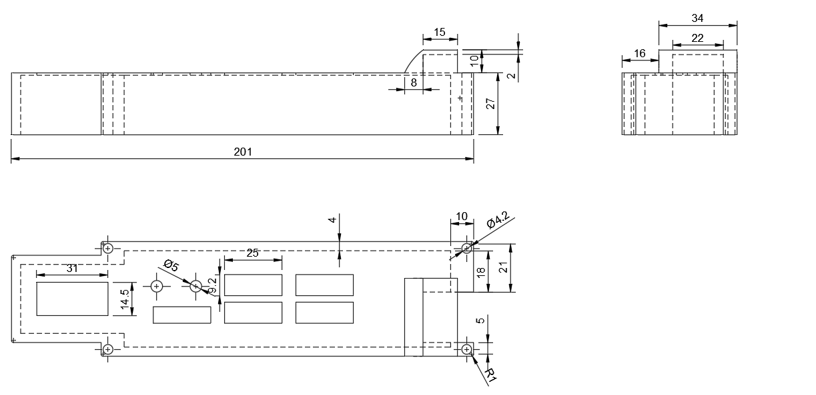

## Figure 19 - Control Panel Top Drawing

## 

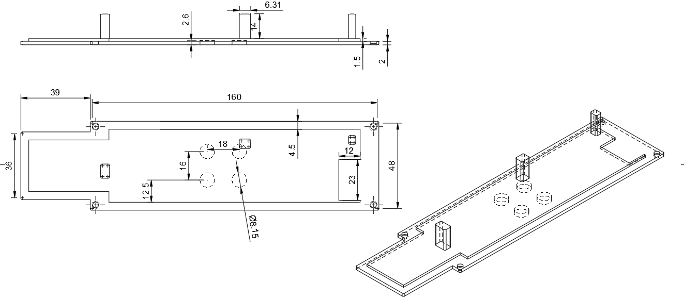

Figure 20 - Control Panel Bottom Drawing

## 

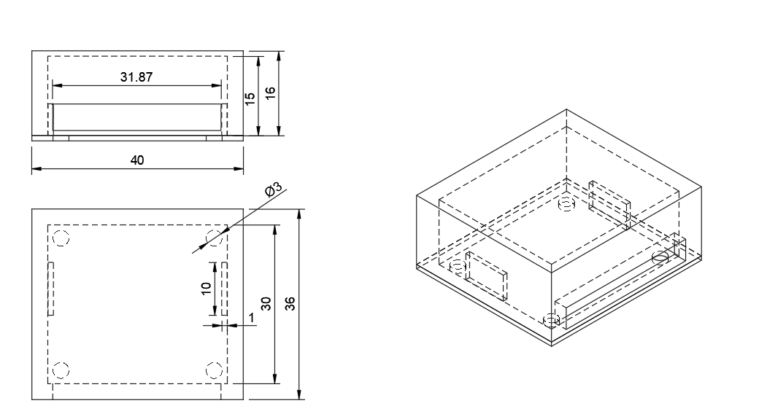

## Figure 21 - AC to DC Converter Drawing

Detailed drawings for designed and 3d printed parts are shown above. All units are in millimeters unless stated otherwise. The bottom of the control panel has protruding sections to hold the electronics against the front face of the panel. Inserts for magnets are also located on the bottom plate of the control panel so the assembly can be attached to the fridge.

# Chapter 4 - Refrigerator’s Circuitry, Microcontroller, and System Interface

# Section 4.1 – Circuitry Development, interface, and programming codes

The Smart Refrigerator’s circuitry includes the custom soldered protoboard that is encased inside the control panel and the external additional wiring and components that tie the control panel into the refrigerator’s normal operating electronic loop as well as connect the fan and temperature sensor. The circuit diagram for the electronics can be seen below in Figure 22. One major criteria for the electronic component selection was their compatibility both with the previously chosen microcontroller, the ESP32 NodeMCU as well as the Arduino IDE. For this reason, the DS18B20 integrated circuit temperature and 4-Digit Display were chosen. These components had already created libraries and tutorials online to reference during the development of the circuit.

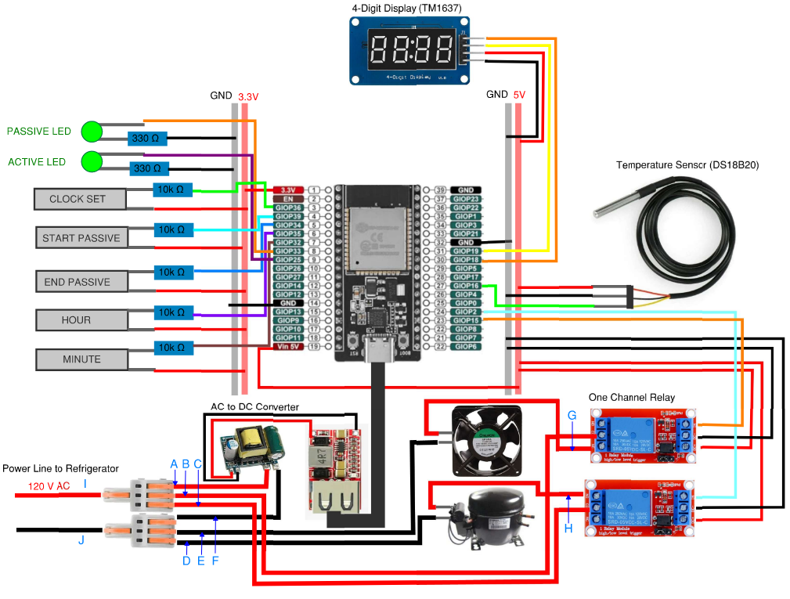

## Figure 22 - Full Refrigerator Circuit Diagram

The layout and wiring was first designed on a breadboard to individually test different component’s functionality and ensure that they could all work together. This prototype circuit was used for the development of the code throughout the semester while the final, refined circuitry was installed in the refrigerator. A photo of the breadboard prototype circuit can be seen below in Figure 23. The prototype circuit was especially necessary in development to test which ESP32 pins were acceptable to use for which components. Though the ESP32 has 38 pins, 32 of which are general purpose input/output (GPIO), many of these pins could only be used for input or output or not at all due to boot up requirements.

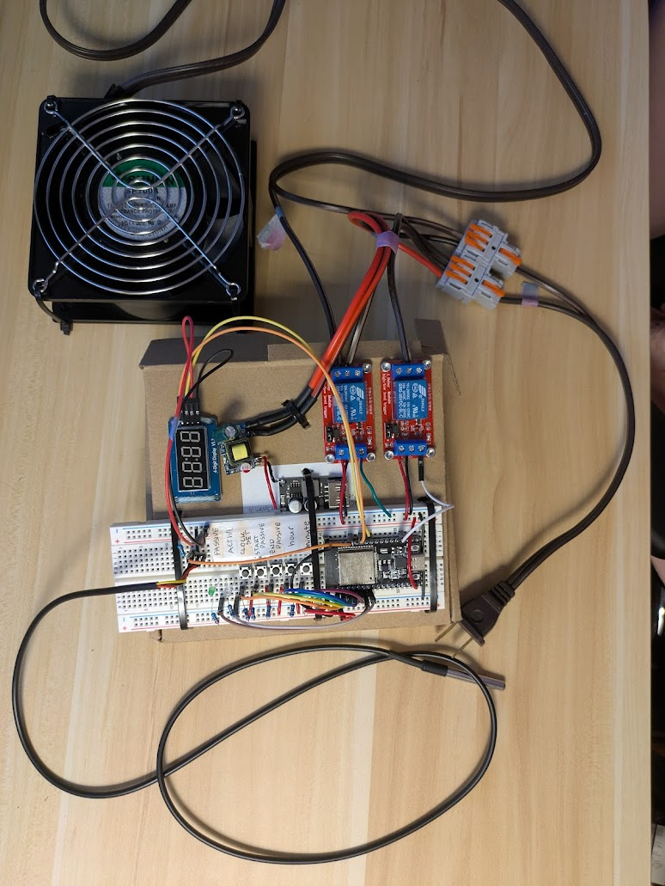

## Figure 23 - Breadboard Prototype Circuit

The final development step involved in the design of the Smart Refrigerator’s electronics was the soldered protoboard’s layout as shown below in Figure 24. The first step in the layout was to place the resistors, buttons, and LEDs on the physical boards and determine the best place for each component for the most attractive control panel interface. Then, these locations were mapped onto a digital recreation of the board in addition to the ESP32 pin locations. The next step was to draw lines to represent wires in the most reasonable path connecting the ESP32 pins to the electronic components. These lines were redrawn several times throughout the soldering process as better routes were determined. The buttons and LEDs soldered directly to the protoboard allow the user to interact with the features of the Smart Refrigerator. The control panel exterior panel will cover the fragile wires, adding rigidity and provide an appealing interface.

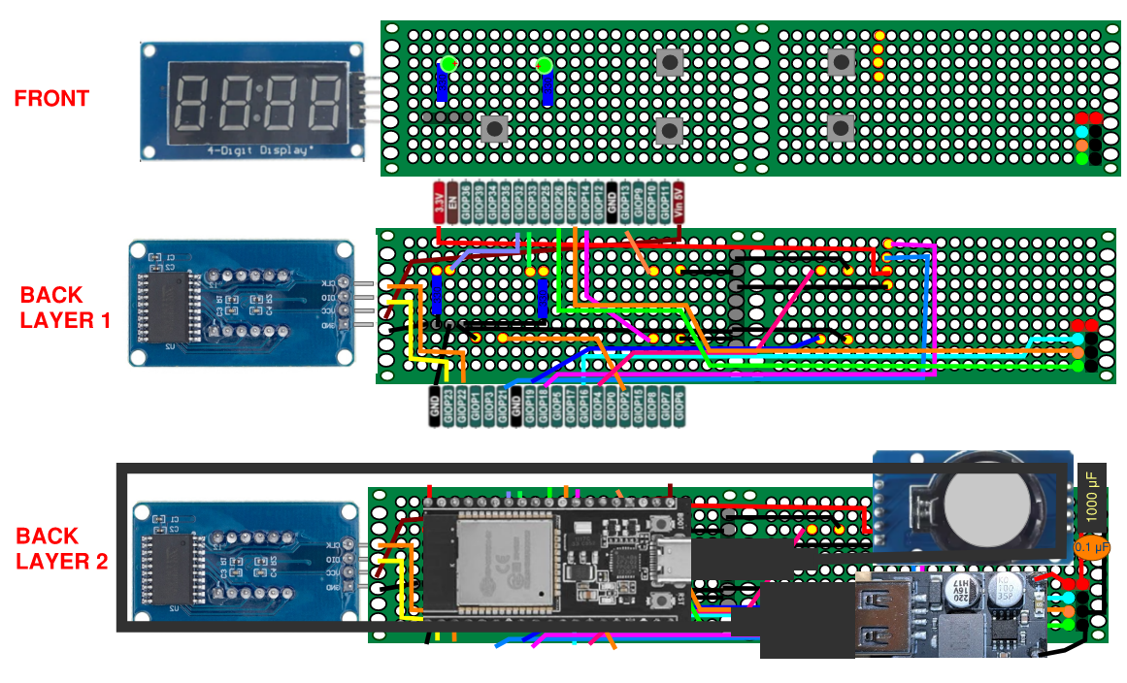

## Figure 24 - Circuit Diagram of Control Panel Protoboard

The user is able to interact with five buttons on the control panel: Hour, Minute, ClockSet, End, and Temp. The Hour and Minute buttons are used in two different ways: to modulate the passive cycle start time, which sets when the system will activate, and the duration time, which sets how long the system will run. Clockset is used to switch between the two modes using the modeDuration variable. By default, the system has this variable set to false and pressing Hour and Minute would increase the startHour and startMinute variables, changing the passive cycle’s start time. When the Clockset button is pressed, it switches modeDuration to true, making it so that when Hour and Minute are pressed, it increases the hours and minutes variables, which changes the duration of the passive cycle. Pressing the End button exits out of duration mode as well as turning off the passive mode when it’s running.

|  |
| --- |

## Figure 25 - Code for Hour, Minute, and Clockset Buttons

After the user inputs the passive cycle’s start time and duration, the program will have the real-time clock module (RTC) track the current time. Once the current time reaches the time set by the user, the passive cycle will activate, shutting down the compressor and entering the running state of the code. In this running state, it acts as a countdown timer while calling a toggleFan function in the code as it counts down. In this function, the temperature sensor reads the temperature in the fridge, and if that temperature exceeds 40℉, the fan will turn on and cool the system along with the heat sinks. The fan will only turn off once the temperature decreases under 37℉.

|  |
| --- |

## Figure 26 - Main Trigger Function Code

# Section 4.2 - Summary of Microcontroller and Electronic Features

There are several features of the control panel’s soldered protoboard that aim to make the interface look appealing while also allowing the board to be taken in and out of its casing for easy modification and troubleshooting throughout the design process.

*Slim Design*

One important aspect of the board’s design is that it is as slim as possible. The smallest possible DIY solderboard pieces were chosen that had just enough width to fit the ESP32. Two pieces were put side by side to have a long and narrow soldering board to work with. Figure 27 below shows how the electronics are placed to fit within the narrow profile of the green DIY solderboard pieces. Furthermore, Figure 28 shows how the components were not layered vertically such that the side profile is also slim.

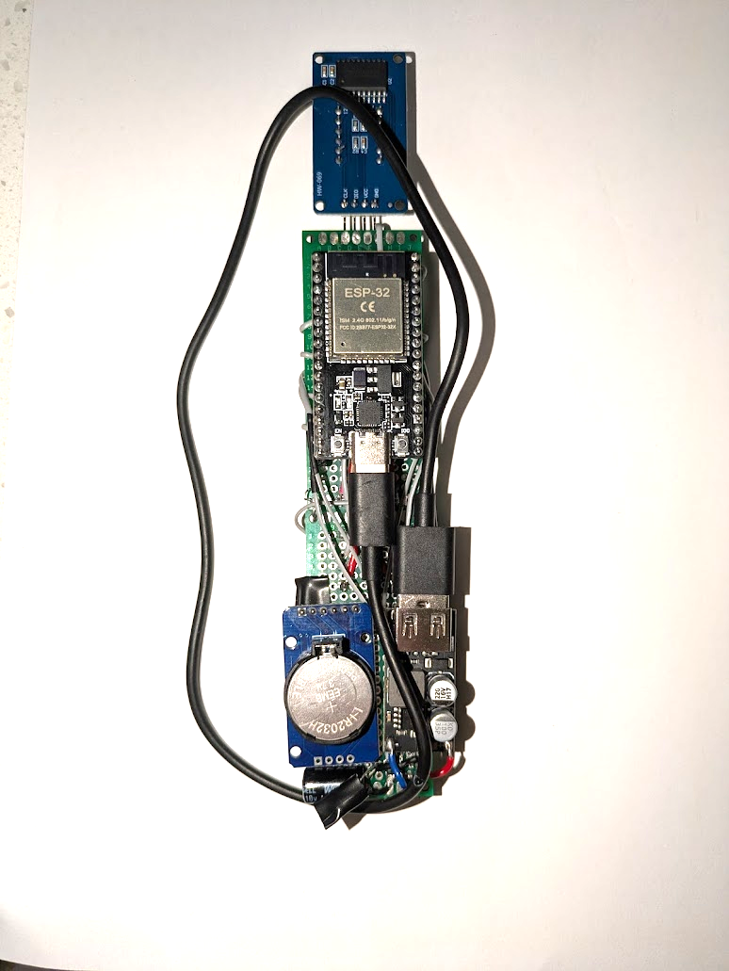

## Figure 27 - Back of Control Panel, Top Layer

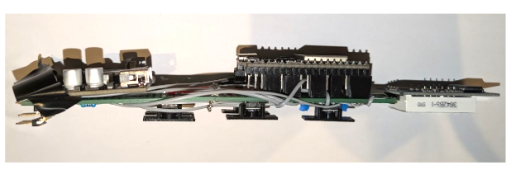

## Figure 28 - Side Profile of Control Panel

*Multiple Layers of Wires, Removable ESP32*

Wires were soldered on both sides of the DIY solderboard pieces. Spreading out the wire density allowed for the connections to be resoldered if necessary, making the board easier to repair if the components were disconnected on accident. Since there are wires on both sides including underneath the ESP32, it was necessary for the ESP32 to be easily removable. Since the ESP32 pins must be connected to the wires while still being removable, female header pins were implemented as shown below in Figure 29.

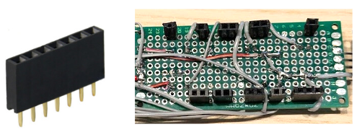

## Figure 29 - Female header pins soldered beneath the ESP32

*Ribbon Cable and Connector*

A ribbon cable was used for the length of wire connecting the control panel to the rest of the electronics at the rear of the refrigerator. An important feature of the cable is that it must be able to be disconnected from the control panel such that the soldered circuit board can be separated from the refrigerator to be modified and troubleshooted as necessary. To do this, an IDC female connector was used with a custom 90 degree male receptor that was created out of several male to male header pins as shown below in Figure 30.

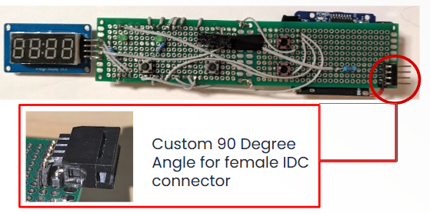

## Figure 30 - Custom Male connection for Female IDC connector

*Single Power Connection Simplicity*

To simplify the electronics, all of the power for the system originates from the existing single three prong power cord from the mini-refrigerator. Three wire splitters rated for AC voltage split the AC power into three different wires: one to the AC to DC converter and two to each of the compressor and fan relays. A buck DC to DC converter steps the incoming voltage from the AC to DC converter to the 6V required from the ESP32 and provides protection from current fluctuation. One channel relays were used for both the fan and compressor loop since these components required AC power.

*Justification of Electronic Components Based on Project Requirements*

The ESP32 NodeMCU provides adequate processing speed and functionality to control the Smart Refrigerator. The ESP32’s processing speed of 240 MHz and 38 pins allow for it to connect to and interact with all of the necessary components of the refrigerator. The integrated circuit temperature sensor has a ± 0.5°C accuracy and ranges from -10°C to 85°C. Since the refrigerator is operating in the range of 33°F - 40°F or 0.6°C - 4.4°C, this is acceptable for the temperature range of the Smart Refrigerator. The accuracy of ± 0.5°C is acceptable because even though the refrigerator’s temperature can reach up to 40.8°F which is higher than the 40°F limit of refrigeration temperature, the refrigeration chamber will only be at this temperature temporarily until the cold air from the passive cycle cools the air back to below acceptable temperatures. This period of time isn’t long enough for the food inside the refrigeration chamber to rise above the acceptable temperature.

# Section 4.3 - Block Diagram

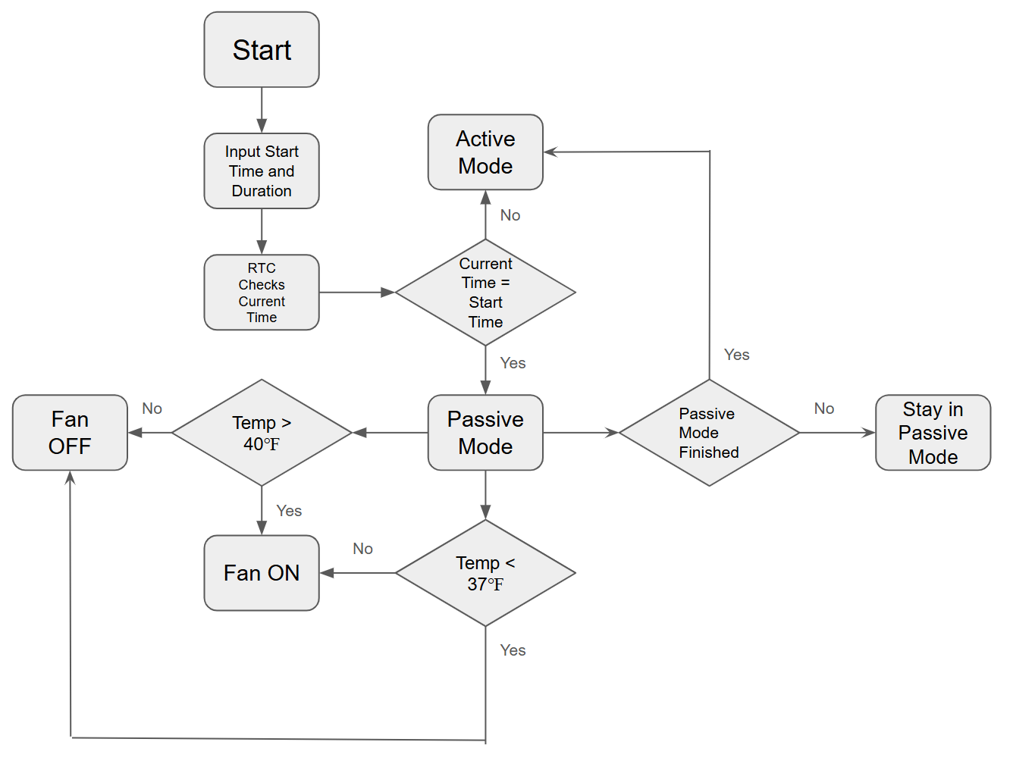

## Figure 31 - Block Diagram

# Section 4.4 - System integration and data acquisition

The electronic system is integrated with the refrigerator’s existing electronics using three way wire splitters and one channel relays. The AC components of the electronics including the AC to DC converter and relays are placed behind the refrigerator’s compressor so that they are close to the three way wire splitters and input power cable to the refrigerator as shown below in Figure 32. As previously described, the control panel’s soldered board is connected to the rest of the refrigerator’s electronics with a ribbon cable that can be attached and removed as necessary. The temperature sensor is connected to the 5V supply from the AC to DC converter with the signal branching from the ribbon cable.

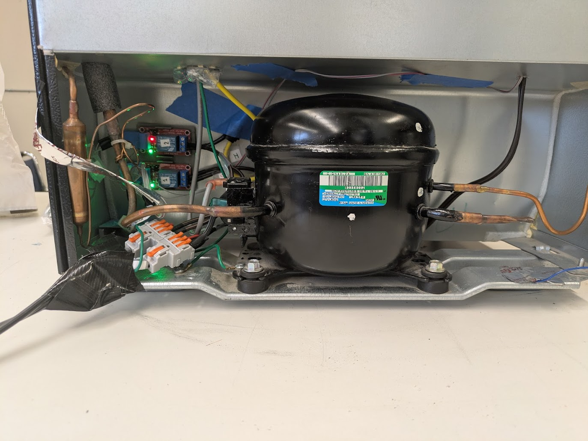

## Figure 32 - Electronics integrated at the rear of the refrigerator

The data acquisition integrated into the microcontroller is limited to the temperature sensor’s reading in the main code loop. However, the microcontroller does not record the temperature profile of the refrigerator. Instead, two devices were used for the data collecting: the HOBO plug load logger and HOBO temperature and RH sensor. These devices record power consumption and temperature over time, respectively.

# Chapter 5 - Prototyping and Fabrication of the Smart Refrigerator

# Section 5.1 - Materials and Fabrication Processes

For this project, the team primarily used ABS Filament and Aluminum. One team member had a larger 3D printer, which produced all of the 3D prints. The team also relied on Gorilla Tape and Flex Seal. The team used 3D printing to keep costs low, everything that could be 3D printed was. The 3D filament was chosen based on its strength and reliability. None of the 3D prints were load bearing, so the team also did not have to perform any force analysis. The team opted for aluminum because it was relatively cheap to acquire, and it had great thermal conductivity. While aluminum has a lower melting point compared to copper, the team was dealing with cold temperatures. Iron and steel were also considered as they are easier to weld and fabricate with, but they do not conduct heat as well as aluminum, are quite heavy, and not as price friendly.

The team used many fabrication processes. One member had a friend, Desmond Chueng, who had personal access to many tools and equipment that the SJSU machining lab did not have. This project used welding, soldering, sanding, CNCing, glueing, 3D printing, drilling, cutting and taping. A mig welder was utilized as the metal in the project was aluminum. A band saw was used to cut the aluminum, and a belt sander was used to make sure all cut edges were safe to handle. The CNC was through Desmond Cheung’s workplace, but was very helpful in drilling holes through the heatsink, which was tricky because of each individual fin. For the adhesives, Gorilla Tape and Flex Seal were chosen because both are very durable and weather resistant, but are still available at local hardware stores. Being durable and water tight was a high priority for the team, they did not want to cut any corners when it came to quality of components while still getting the most out of their budget. Lastly, all of the wires were soldered to establish strong consistent connections between the breadboard and wires. This also provided peace of mind that other more temporary ways to connect wires could not. The team had to move the prototype many times to and from campus to conduct testing, so wire connection quality was important.

# Section 5.2 - Assembly Procedures

For the prototype, the team used the following assembly processes; cutting, CNCing, drilling, welding, soldering, sanding, gluing, taping, and 3D printing. To construct the control panel, the team used a 3D printer to print the casing and buttons. The wires were soldered onto a breadboard which was then glued into position. The 3D printed buttons were also glued onto the circuit buttons on the breadboard. These buttons consisted of two parts, one part that fit onto the button and through the control panel casing, the other a larger piece that would not fit through the casing that was put on after so that the control panel gaps were concealed. Labels were also printed and glued onto the buttons so that the project was as user friendly as possible. See below in Figure 33 for the printed buttons, casing and button labels, as well as the final iteration of the control panel.

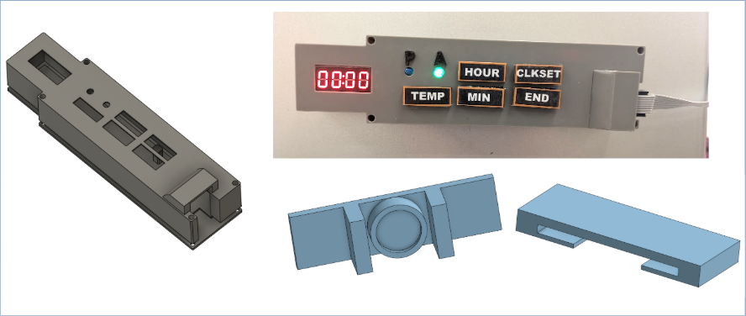

## Figure 33: Control Panel Casing and Buttons with Labels

For the ice casing assembly, the assembly process began with using a band saw to cut the aluminum heat sinks and plates to size. After, a belt sander was used to ensure the edges would be smooth and safe. After, a MIG Welder was used to tack weld the two pieces of aluminum together to meet the required dimensions of the freezer compartment. Once the heat sinks were welded together, Desmond Cheung took them to his workplace to use a CNC to cut holes at each corner for the hardware, which can be seen below in Figure 34. Simultaneously, the frames for the casings were 3D printed, they were designed with a little hole on the side so that water could be added and drained. M3.5 Hardware was used to adhere the welded heat sinks to the 3D printed frames and to the aluminum plates. Sealant was then used to seal the entire assembly so that it was water tight. This took multiple tries to ensure the assembly was waterproof. To fill up the water casings, the team used a 1ml pipette to fill each casing up with the precise amount of water to account for the expansion of ice. One way to ensure the casings were water tight was applying sealant on both the inside and the outside of the seams of the aluminum plates and the casings, see Figure 34 below.

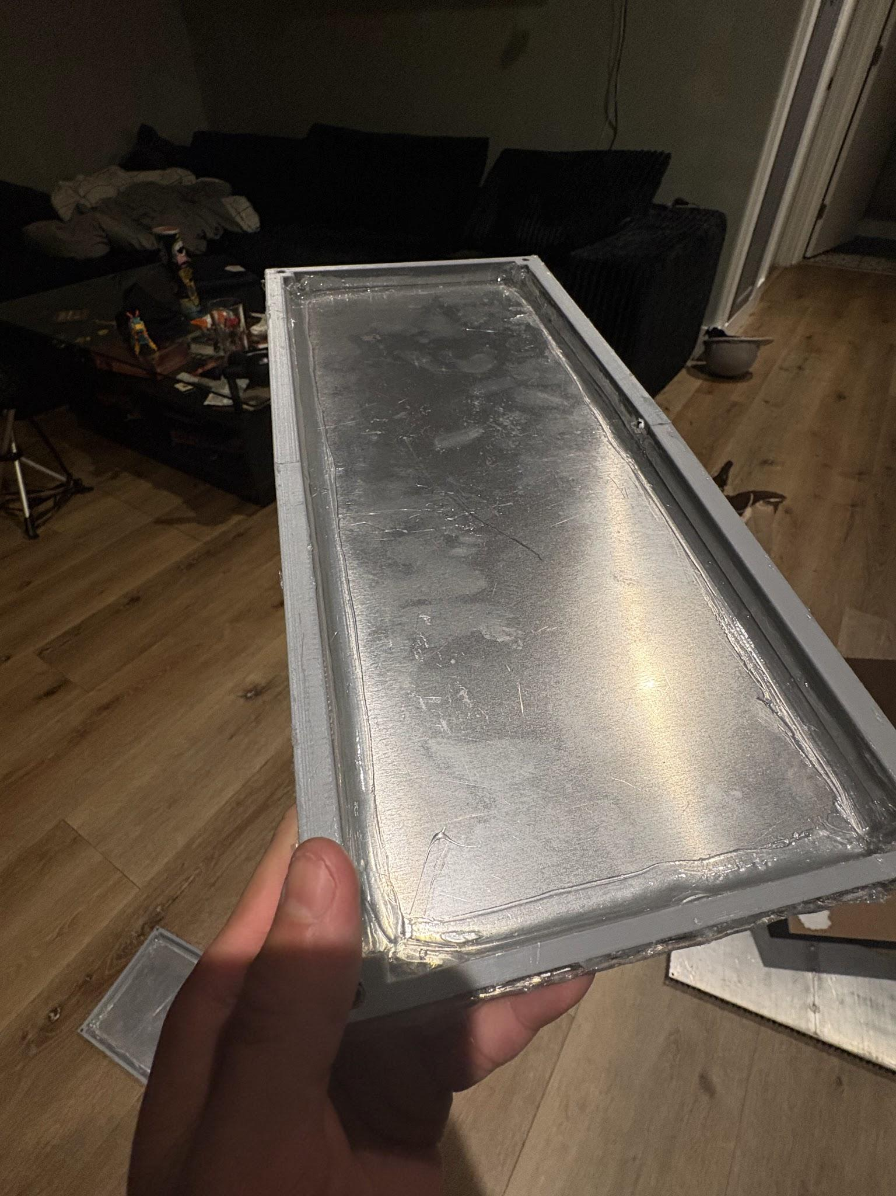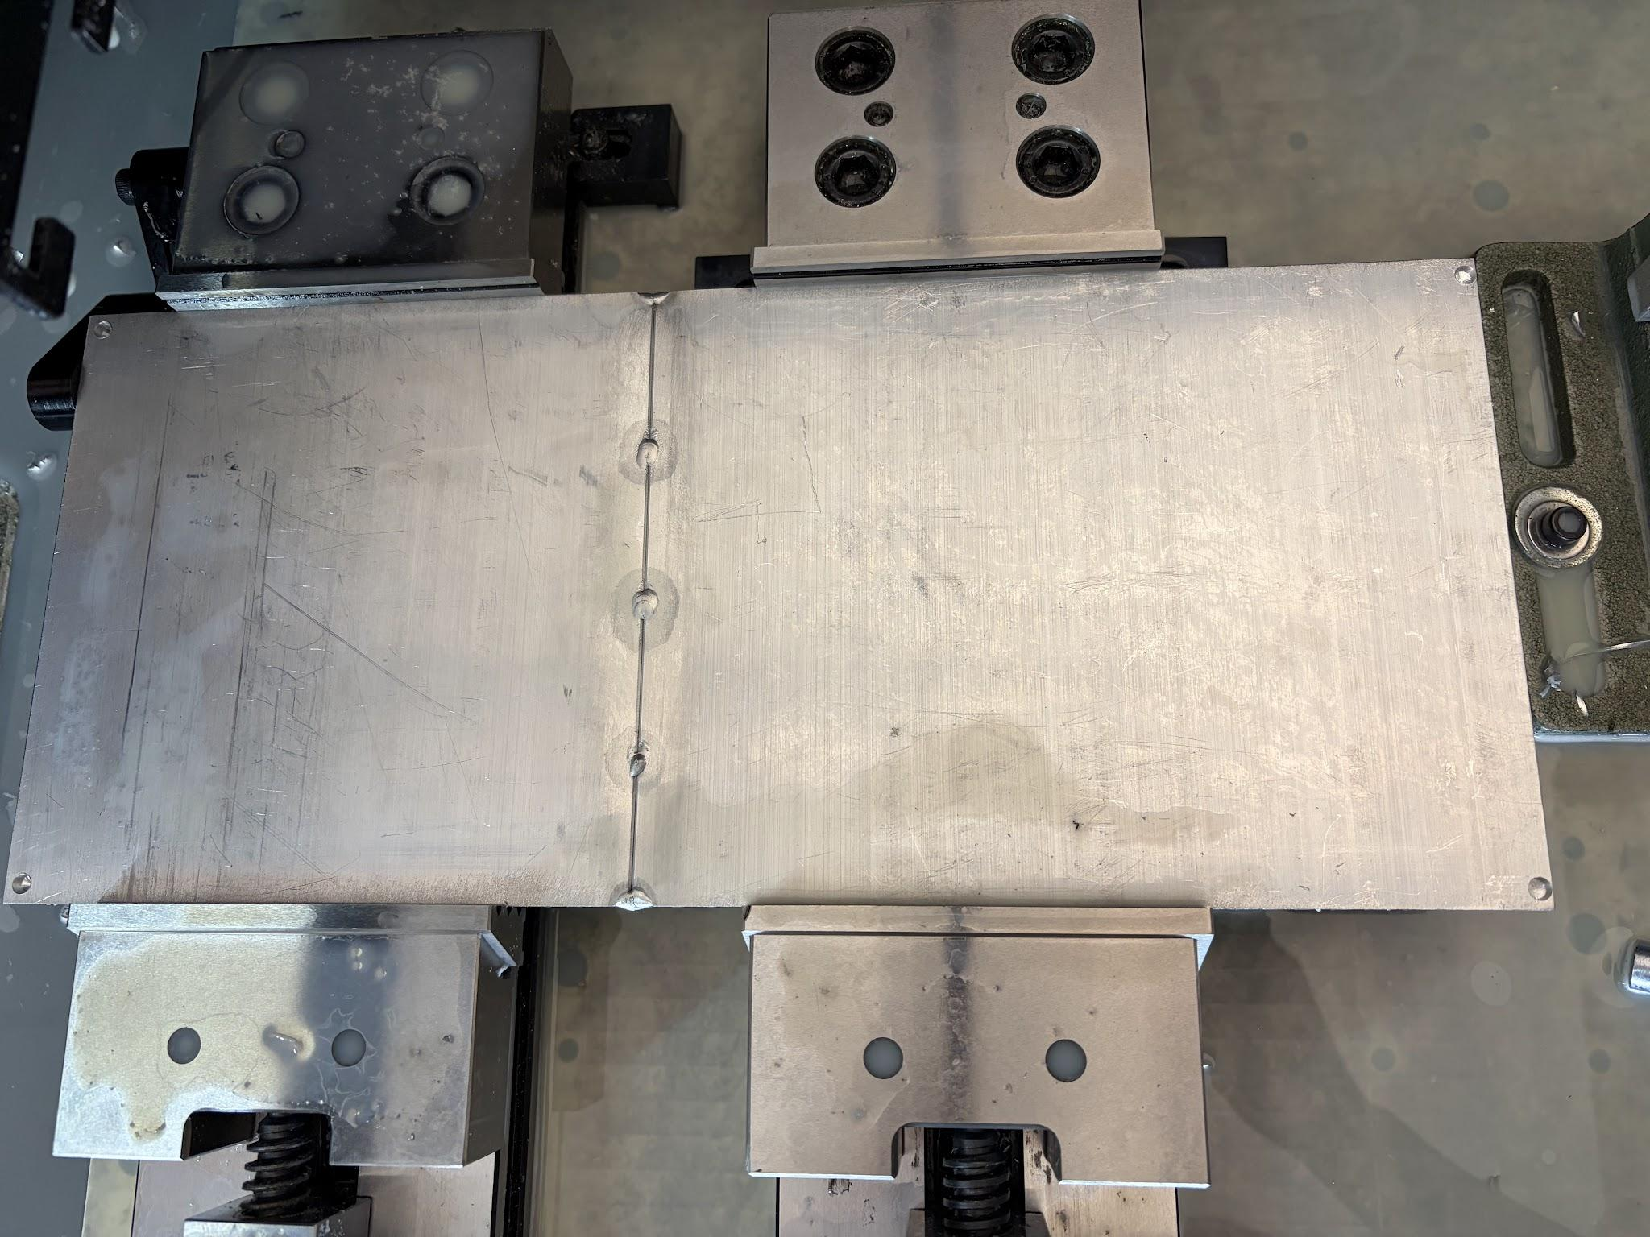

## Figure 34: Flex Seal on the Inside of a Plate and Welded Heat Sink Before CNC

Moving onto the fridge itself, a drill was used to create a hole through the mini refrigerator to run the fan power cord and temperature sensor through. Tape was then used to seal the hole with the wires running through it. In addition to this, the team had to splice the main power cord to the refrigerator so that it powered both ESP32 boards and the fan. Two one channel relays were used with quick connect pins so that the prototype could disconnect from the microcontrollers and worked on from home while the fridge remained on campus. All of the wires were also tagged to make wiring and rewiring convenient and simple. An AC to DC current converter was also necessary in the construction of the prototype to power the microcontrollers from a traditional outlet. Lastly, tape and cardboard were used to section off portions of the freezer compartment to direct flow from the back of the evaporator coil to the front of the ice casing assembly into the main compartment.

# Section 5.3 - Fabrication Challenges

One of the biggest obstacles during the fabrication process was water proofing the ice casings. The ice casings needed to be watertight and withstand multiple freezing and defrosting cycles. One design parameter was for it to be completely airtight so that each casing was a closed system, this way a consistent amount of ice was frozen for each passive cycle. Because the heatsinks were welded, they experienced some heat warping which created gaps when placed against the 3D printed frame. This led to multiple waterproofing trials. Waterproofing the ice casings took nearly two weeks longer than planned, which delayed testing. Below in Figure 35**,** the gaps can be seen of the welded heatsinks along the frames before any waterproofing took place.

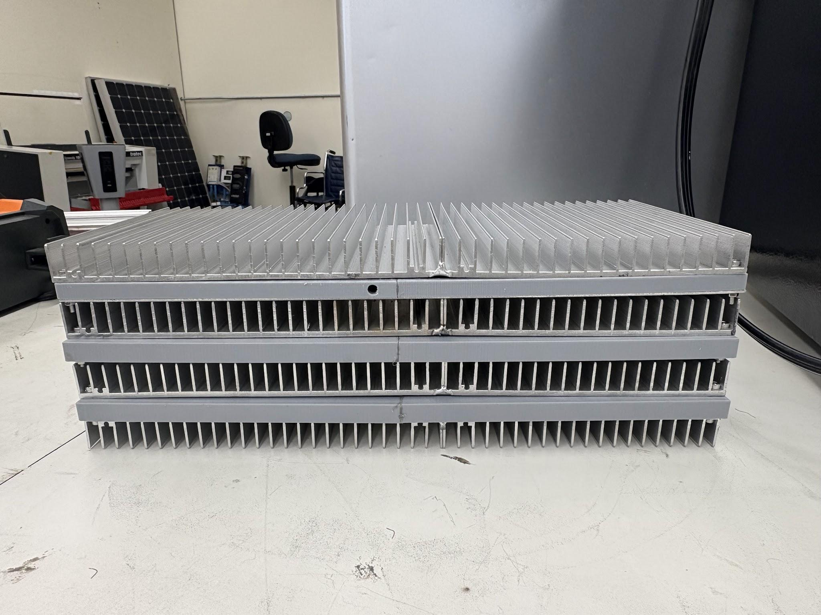

## Figure 35: Gaps in Heatsink

Another fabrication challenge the team encountered was the fan positioning. Due to the nature of the evaporator coil and the layout of the freezer compartment, the fan was not able to be angled towards the center very much. The team overcame this by using the belt sander and shaving the casing down. With one half of the fan casing shaved down, the fan could be positioned close to the wall and angled properly. Prior to this sanding the square casing would rub against the rounded edges of the refrigerator’s freezer compartment. Below in Figure 36, are the before and after sanding down the fan. Unfortunately, even after the sanding, the fan only angled another 10 degrees towards the center, which was not satisfactory.

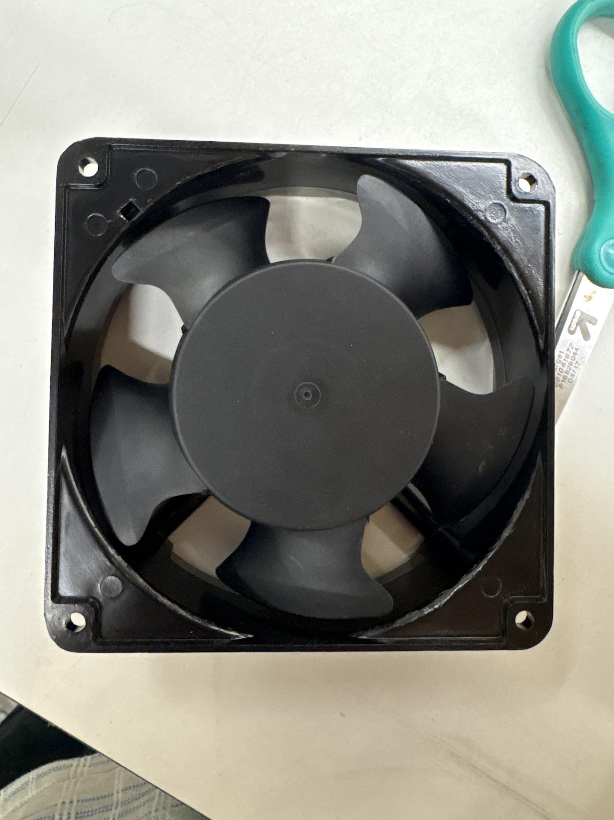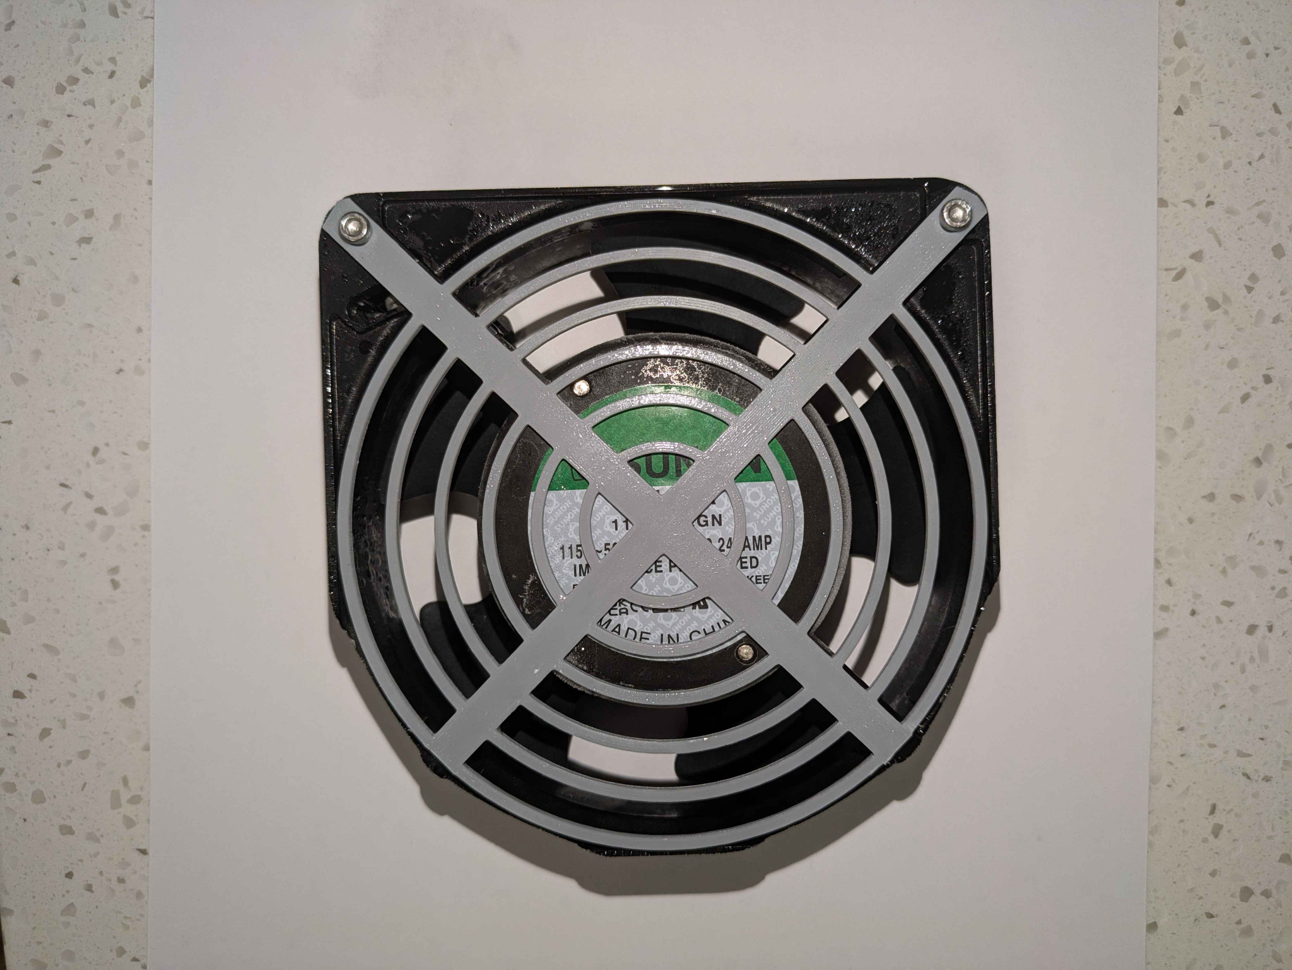

## Figure 36: Before and After Shaving the Fan

# Section 5.4 - Economic Analysis and Societal Benefits

The refrigerator utilizes the passive cycle during peak utility hours, heavily reducing electricity load during the most expensive time of the day. About 7% of electricity cost was reduced due to the offset from peak hours to off-peak hours. Because less power was being used during periods with high utility rates, electrical cost saving annually results in about $12.93.

At this point, the prototype does not provide much of a societal implementation incentive; however, it could if there was a way to make a cheaper version that could be easily manufactured. An example of this could contain prefabricated casings integrated in the freezer walls for a cost-effective design. This would be more accessible for consumers and thus be more feasible as a societal benefit.

# Section 5.5 - Design to Meet Safety, Environmental, and Engineering Codes

Safety was a big priority as refrigerators must be operational at all times, else the food inside spoils. By remaining aware of this, goals were placed at the beginning of the year to meet FDA required maintenance temperature of below 40 degrees Fahrenheit. The product was made openable from the inside to follow the refrigerator safety act.

By not altering the door mechanism, the fridge remained compliant towards this act. As for maintaining the FDA’s requirement, the fridge successfully began to start running the fan over the thermal mass when reaching an internal temperature of about 41 degrees fahrenheit until the temperature dropped to an internal temperature of 37 degrees or below.

# Section 5.6 - Final System Overview

Now for an overview of the final system and the modifications that differ from the initial design. Initially, the plan was to cut the freezer section and evaporator coil within this section to create a bigger volumetric section to hold a larger thermal mass. This quickly changed and the design pivoted upon discovery of the need for a certified technician in order to work with the refrigerant for purposes of discharging and recharging the system.

The task was then to create a thermal mass that could fit in the freezer portion that the original fridge contained. The fan was able to fit, however, it had to be placed in the corner because there was no way to cut out a center hole for the air to flow. The corner hole that was already open had to be used instead. This resulted in the curved vent design with tape to help the air to flow across the width of the heatsinks.

Height was one of the main concerns when shrinking the size of the thermal mass. In order to shrink this dimension, the aluminum tubing was not used. This would have added extra height on top of the heat sinks. Instead, 3D prints were made for the rectangular enclosure and heat inserts were added to screw these enclosures and the heat sinks together.

# Chapter 6 - Testing and Result Analyses of Refrigerator’s Operation

# Section 6.1 - Testing Plan and Methodology

To evaluate the Smart Refrigerator’s performance, three tools were rented from PG&E’s Tool Lending Library including a hotwire anemometer, HOBO plug load logger, and HOBO temperature and RH logger. The hotwire anemometer was used to measure the velocity every 5 fins across the heat sink assembly’s outlet by holding the tip of the device directly against the spaces between the fins as shown below in Figure 37. The measurement was repeated twice and then averaged for each 5 fin long segment. Measurements were taken for two different cases to compare: one with a cardboard vane between the fan and the heatsink and one without.

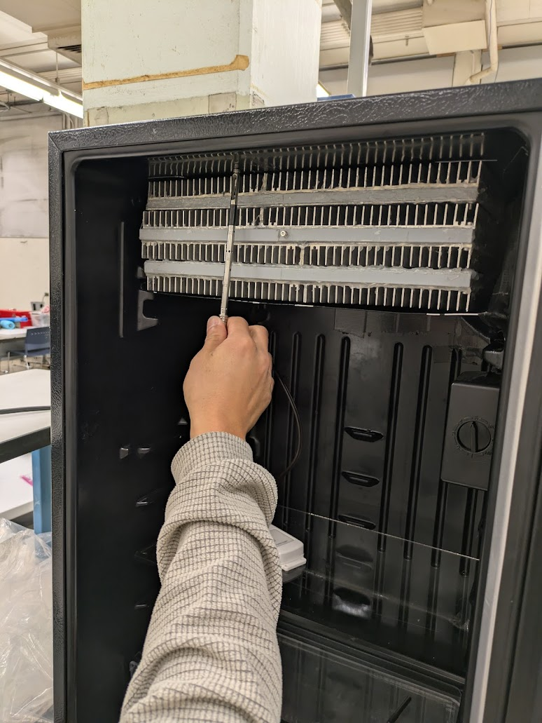

## Figure 37 Velocity measurements with hotwire anemometer.

To measure the instantaneous power of the refrigerator to evaluate the load shifting potential, the plug load logger was connected in series with the refrigerator’s power cable such that the logger could read the power pull of the refrigerator. The HOBO plug logger recorded the instantaneous active power that the refrigerator used for every minute of operation. The HOBO temperature logger was placed inside the refrigeration chamber close to the temperature sensor integrated with the microcontroller. The temperature logger recorded the temperature at every minute of operation.

After setting up the temperature and plug load loggers, the Smart Refrigerator was powered on to be used as a refrigerator. It was quickly determined that the maximum coldness setting on the mini refrigerator was necessary for the heat sink assembly to become completely frozen for success during the passive cycle. For several days, both the active and passive cycle were run in their entirety to evaluate the energy consumption and temperature of the refrigeration chamber. During the passive cycle, two actions were taken throughout the three hour period to mimic typical use of the refrigerator including opening the door for a duration of time and placing bottles of water onto the shelf. These actions were repeated several times throughout the passive period to observe the fan turning on and then shutting back off.

# Section 6.2 - Data Analysis and Results

To analyze the success of the prototype at dispersing the air evenly through the heat sink assembly, the average velocity for each segment was overlaid on top of its retrospective fin area. Color shading from green to red was overlaid on the cells to emphasize which areas had better and worse airflow. The profile for the experiment without the vanes is shown below in Figure 38. The numbers over each segment represent the average air speed in m/s.

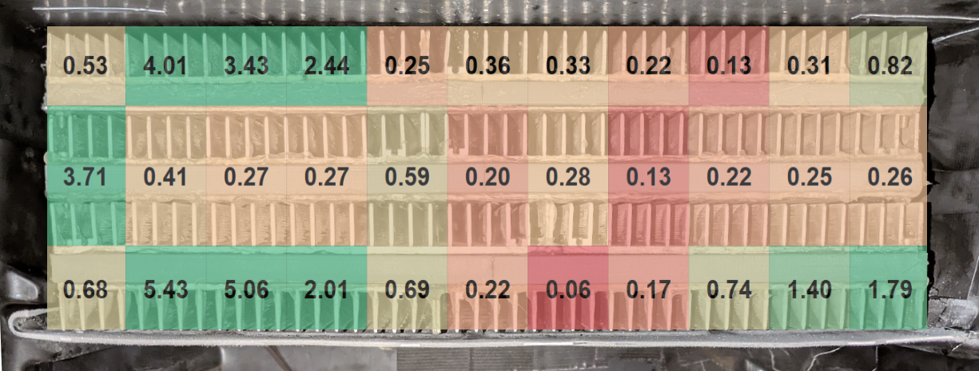

## Figure 38 - Velocity profile of heat sink face without vane install.

The average velocity through the face of the heat sink is 1.14 m/s without the vane and 1.1 m/s with the vane. To compare the rate of airflow to the theoretical value, the flowrate can be calculated from this average velocity. Without the vane, the average flow rate can be calculated to be 45 CFM based on velocity measurements. The measured average velocity, 1.14 m/s differs slightly from the expected velocity at the fan’s operation point, 1.7 m/s. The calculated airflow from the experimental velocity measurements, 45 CFM, greatly differs from the expected operation point, 85 CFM. This difference in airflow and velocity is likely due to the angle and location that the fan is placed at. Furthermore, the gap of air on the left side of the heat sink is likely a source of leakage.

The temperature and active power recorded from the HOBO loggers was plotted in Excel. Calculations were performed on the data to determine and then compare the energy consumption during the active and passive period as well as how much additional energy is required to freeze the heat sink assembly. The average power during the active cycle at the maximum coldness setting is 48.2 W which results in the energy consumption of 144 Wh for three hours or 422 kWh per year of constant operation. In comparison, the electricity consumption during the three hour passive period is 30.7 Wh. The additional energy used to refreeze the heat sinks after each passive period is on average 21.6 Wh/day. From these energy consumption values, the annual amount of energy that is shifting from peak to off peak is 29.6 kWh resulting in $12.93 dollars of projected savings based on the 5-8pm residential time-of-use PG&E utility rates in 2025. Compared to the annual cost for operation without the retrofit, $184.26 dollars, this cost savings is a 7% reduction in electricity cost per year.

Since the plug load and temperature logger recorded thousands of data points of several an entire week, it is best to choose a single day to analyze the performance of the refrigerator on a plot. Figure 39 represents the instantaneous power and temperature recorded from the loggers on December 5th, 2025.

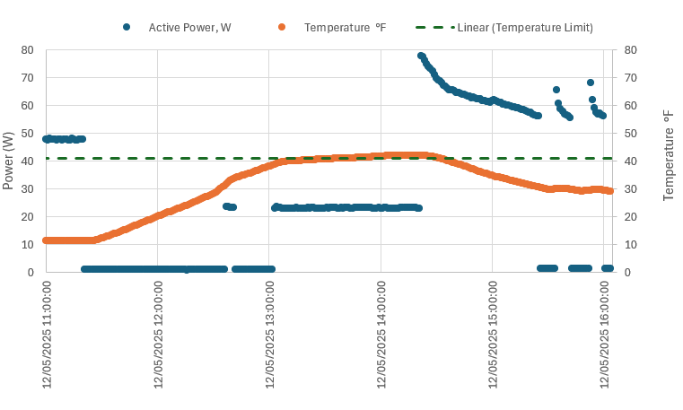

## Figure 39 - Instantaneous power and temperature recorded on December 5th, 2025

In Figure 39, the passive cycle begins at 11:15 am. At first, the electricity consumption is near zero and the temperature is in the freezing range, below 32°F. When the passive cycle first begins, the temperature is cold enough that the additional cooling from the fan is not necessary. After the refrigerator door is opened and bottles are added to the refrigerator, the temperature begins to steadily increase. The fan briefly turns on around 12:40 pm even though the temperature is not above the threshold. This is likely due to warm air that may have briefly entered the refrigerator around the microcontroller’s temperature sensor but didn’t remain long enough for the temperature of the entire chamber to change. The fan quickly turns back off and remains off until the temperature goes above the temperature threshold around 1:00 pm where it turns on and stays on for the remainder of the passive period. At the end of the passive period, there is a peak in the energy consumption, showcasing the additional energy required to bring the heat sink assembly back to its completely frozen status. Also note that there is a different pattern of power during the active cycle after the passive period as compared to before. This is because the refrigerator was switched from the maximum coldness setting to 3/5 coldness so the compressor is cycling on and off to hit the refrigeration temperature setpoint. During the passive period, the temperature was above the threshold for 21% of the duration, which is not ideal.

# Chapter 7 - Conclusions and Future Work

# Section 7.1 - Evaluation of Design and Calculations

The team’s design was overall a success. The ice casing assembly held water, froze, and fit within the mini refrigerator’s freezer compartment. All of the wiring and relays fit within the back compartment with the compressor, keeping the mini refrigerator’s footprint the same. The design utilizing two microcontrollers working in tandem was successful. The control panel had an intuitive design and had all of the necessary buttons. While there was a lot of improvisation along the way, this prototype satisfied all of the project objectives outlined at the beginning of this year. The fan was able to blow enough air over the fan casings to maintain an internal temperature of around 39 degrees fahrenheit.

In regards to calculations, the refrigerator was successful in cycling through the active and passive modes, saving energy, offloading energy off during peak hours, and evaluating airflow through the ice casings. The calculations were correct in approximating the volume of ice necessary to keep the fridge cold. None of the ice casings exploded from too much water. As mentioned prior in Figure 39, the best testing run of the finished smart refrigerator. The prototype was able to keep the mini fridge internal temperature below the temperature setpoint for approximately 80% time on December 5, from 11:20 to 2:20pm. The prototype was able to save up to $13 a year in energy costs. The team had a margin of roughly 55% when it came to the calculated CFM in comparison to the actual CFM calculated from the anemometer and velocity profile.

# Section 7.2 - Comparison of Experimental Results to Design Specifications

The analysis of the data from the plug load and temperature logger show that though the refrigerator’s control system is operating as expected and does save the user money on electricity cost by shifting load from peak to off peak periods, the temperature does not stay below 40°F for the entire duration of the period. The sample from December 5th showed that the temperature was above the threshold for 21% of the passive period duration and that the fan was not able to provide the necessary cooling for that time period. Due to this issue, the refrigerator does not meet the design specifications of maintaining the refrigeration chamber at or below 40°F at all times.

Furthermore, the velocity profile of the heat sink’s face is not evenly dispersed and has several areas with very low velocity, representing spots where there is wasted potential for additional cooling. It is likely that this poor airflow distribution is the reason that the refrigeration temperature is not able to keep refrigeration temperature 100% of the time.

# Section 7.3 - Reflection on Team Collaboration

The team was mostly successful in collaborating over the year throughout this project. They executed their project without any major conflicts or disagreements. One thing that was frustrating was at the beginning of the year a time and day was set for a weekly checkup meeting, but attendance from all team members was not consistent. In addition to this, the communication was not equal from all members of the team. However, the team was able to overcome this, especially as deadlines rolled in. It is also worth mentioning that three out of five group members were working 30 or more hours a week in addition to taking classes and this project. One thing that could have improved team collaboration would be to get each other's phone numbers, the group’s primary form of communication was discord which had varying levels of responsiveness throughout the group. One thing the team did well was meeting on campus. The team had a designated time and day of the week to meet in person, and all members had very consistent attendance. Another way the team collaborated well is that each team member brought unique ideas when it came to overcoming problems, and all team members felt comfortable to share solutions, no matter how silly they might sound. With this in mind, the team had a strong sense of unity and ownership of the project.

# Section 7.4 - Cost Analysis Conclusion

To build on the cost analysis, it was determined that the product's return on investment was about fifty years which is not ideal considering the life of the fridge itself, could be somewhere around thirty years in good conditions. In conclusion, it would be reasonable to eliminate cost within the passive cooling system to save more money on the front end and for the user's initial investment.

Something that could help us accomplish this is by getting rid of the heat sinks entirely as this was a large material cost for the project. Instead, coils could be used to contain the water which could potentially save a lot of time creating the thermal mass. This would also improve airflow and improve heat transfer, ultimately reducing the need to run the fan. This would in turn further reduce energy consumption.

# Section 7.5 - Limitations

One of the biggest limitations of this project was the fact that to freeze the ice casing assembly, the mini refrigerator had to be set at the max coldness setting. In doing so, the internal temperature would reach as cold as 20°F, which would freeze not just the ice casings but everything else placed in the fridge. This is primarily because the lowest layer on the ice casing would freeze as it contacts the evaporator coil, but the two upper layers are farther away. This limited the project as the mini fridge no longer kept its contents around 37 °F, it froze them and no longer satisfied the project objective.

The final limitation for this project was the ice casing and fan compartment size. This section was not expanded by cutting the evaporator coil, which was part of the initial design. The reason the size of the freezer compartment is important is it allows for larger ice casings and more layers which increases the thermal mass, and allows the fan to be situated in a more central position, which increases airflow over the ice casings, and produces more cooling. In addition to this, if the fan is in a central location, it allows the fan to produce less turbulent flow, allowing for a more consistent velocity profile. Increasing the CFM output directly increased the cooling capacity of the prototype.

# Section 7.6 - Potential Improvements and Future Development

Future iterations of this project could address these limitations through both mechanical and control-system improvements. One potential improvement would be having a closed-loop temperature control system within the refrigerator instead of relying on the refrigerator’s maximum coldness setting. This could be done by either using a refrigerator with a separate freezer compartment or creating one from scratch. This way, the ice casings would freeze, and the system could be maintained at around 40℉, allowing the fridge to function at its intended temperature.

Another improvement could involve optimising the fan and ice casing to improve heat transfer uniformity. Since the lower layers of ice casings freeze first because of their direct contact with the evaporator coil, future designs would distribute cooling more evenly across all layers. The fan placement could also be adjusted close to the center of the ice casings, improving the airflow distribution. These improvements would increase the overall performance and efficiency of the system.

# References

Edinger, M. (2021, May 14). PG&E and other utility companies automatically changing rate plans. Here’s how to opt out. KMPH. https://kmph.com/news/local/gallery/pge-and-other-utility-companies-automatically-changing-rate-plans-heres-how-to-opt-out?photo=1

EIA’s residential energy survey now includes estimates for more than 20 new end uses. (n.d.). Www.eia.gov. https://www.eia.gov/todayinenergy/detail.php?id=37813

Garber-Slaght, R. (2013, March). Passive Refrigeration. Cold Climate Housing Research Center; CCHRC. <https://cchrc.org/wp-content/uploads/media/passiverefrigeration.pdf>

U.S. Bureau of Labor Statistics. (2025, March 1). Electricity Per KWH in U.S. City Average. FRED, Federal Reserve Bank of St. Louis. https://fred.stlouisfed.org/series/APU000072610

Sustainable Transformation: Trane’s Thermal Energy Storage System at 11 Madison Avenue,

NYC. (2024). Trane. <https://www.trane.com/commercial/north-america/us/en/about-us/newsroom/case-studies/commercial-real-estate/11-madison-avenue0.html>

# 

# ‌Appendix A: Detailed Calculations

### Table 7 - Nusselt Number Depending on Flow Condition

|  | Laminar | Turbulent |
| --- | --- | --- |
| Developed | Refer to Table 8 | $Nu = 0.023{Re}^{0.8}{Pr}^{0.4}$ |
| Developing | $Nu = 3.66+\frac{0.065(D/L)RePr}{1 +{ 0.04[(D/L)RePr]}^{2/3}}$ | $Nu = 0.023{Re}^{0.8}{Pr}^{0.4}$ |

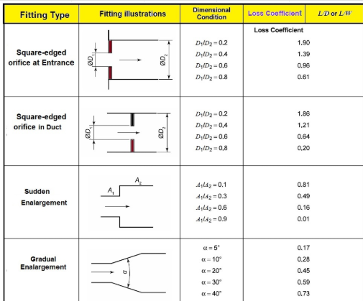

## Figure 40 - Loss Coefficient due to Expansion and Contraction

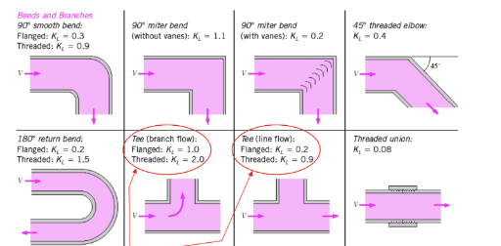

## Figure 41 - Loss Coefficient due to Bends

### Table 10 - Nusselt Number for Constant Surface Temperature given Width a and Height b

| a/b | Nu |
| --- | --- |
| 0.1 | 2.61 |
| 1 | 2.98 |
| 2 | 3.39 |
| 3 | 3.96 |
| 4 | 4.44 |
| 6 | 5.14 |
| 8 | 5.6 |

### Table 11 - Water, Ice, and Air Properties

| Water Properties | | |
| --- | --- | --- |
| Description | Value | Variable |
| Specific heat of water (kJ/kgC) | 4.184 | cp_wat |
| Density of water at 20 C (kg/m^3) | 998.2 | dens_wat |
| Ice Properties | | |
| Description | Value | Variable |
| Specific heat of ice (KJ/kgC) | 2.06 | cp_ice |
| Density of Ice (kg/m^3) | 917 | dens_ice |
| Latent heat of fusion (kJ/kg) | 334 | Latent_ice |
| Thermal conductivity of ice (W/mK) | 2.22 | k_ice |
| Air properties | | |
| Description | Value | Variable |
| Specific heat of air (KJ/kgC) | 1.005 | cp_air |
| R value of air (kJ/kg) | 0.287 | R_air |
| Atmospheric pressure (Pa) | 101.325 | P_atm |
| Kinematic Viscosity - v (m^2/s) | 0.0000146 | kin_vis_air |
| Dynamic Viscosity - mu - (Ns/m^2) |  | dyn_vis_air |
| Prandtl | 0.71 | Pr |
| Thermal conductivity of air (W/mk) | 0.02459 | k_air |

### Table 12 - Shell Surface Area and Heat Transfer Through Walls Calculation

| Surface Area Outer Shell |  |
| --- | --- |
| Height (in) | 31.75 |
| Depth (in) | 18 |
| Width (in) | 18 |
| Height (m) | 0.81 |
| Depth (m) | 0.46 |
| Width (m) | 0.46 |
| Sides area (m^2) | 0.369 |
| Top area (m^2) | 0.209 |
| Front/back area (m^2) | 0.369 |
| Total Outer surface area (m^2) | 1.684 |
| Surface Area Inner Shell |  |
| Height (in) | 29 |
| Depth (in) | 15.5 |
| Width (in) | 14 |
| Height (m) | 0.7366 |
| Depth (m) | 0.3937 |
| Width (m) | 0.3556 |
| Sides area (m^2) | 0.28999942 |
| Top area (m^2) | 0.13999972 |
| Front/back area (m^2) | 0.26193496 |
| Total Inner Surface Area | 1.244 |
| Heat transfer through walls calculation | |
| Insulation thickness - L (m) | 0.05 |
| Estimated k value (W/mC) | 0.36 |
| Interior h value (W/m^2C) | 10 |
| Exterior h value (W/m^2C) | 10 |
| Rconv, interior air | 0.080 |
| Rcond, insulation | 0.234 |
| Rconv, exterior air | 0.059 |
| Rtotal | 0.374 |
| Q_dot (W) | -49.0 |
| Q_dot (kW) | -0.049 |

### 

### Table 13 - Inputs and Preliminary Calculations for Heat Transfer Simulation Spreadsheet

| **Length and Depth of Fin** | |
| --- | --- |
| Length of block (in) | 6 |
| Depth of block (in) | 15.748 |
| Length of block (m) | 0.15 |
| Depth of block (m) | 0.40 |
| Area of block (m^2) | 0.061 |
| **Fin Parameters** | |
| Layers of ice | 3 |
| Height of fins (in) | 0.669 |
| Fin thickness (in) | 0.043 |
| Fin spacing (in) | 0.246 |
| Height of fins (m) | 0.017 |
| Fin thickness (m) | 0.0011 |
| Fin spacing (m) | 0.006 |
| Number of fins | 218 |
| a/b (spacing/height) | 0.4 |
| Cross sectional area PER FIN (m^2) | 0.000106 |
| Channel Perimeter PER FIN (m) | 0.040 |
| Hydraulic diameter (m) | 0.0106 |
| Total surface area (m^2) | 1.34 |

### 

# Appendix B: Detailed Simulation Results and Computer Programs

Note that the spreadsheet used for the fin heat transfer calculations is essentially the detailed simulation and the results are provided in Section 3.2

# Appendix C: Programming Codes and Schematics

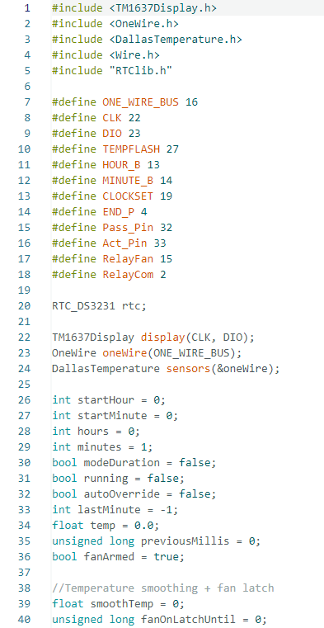

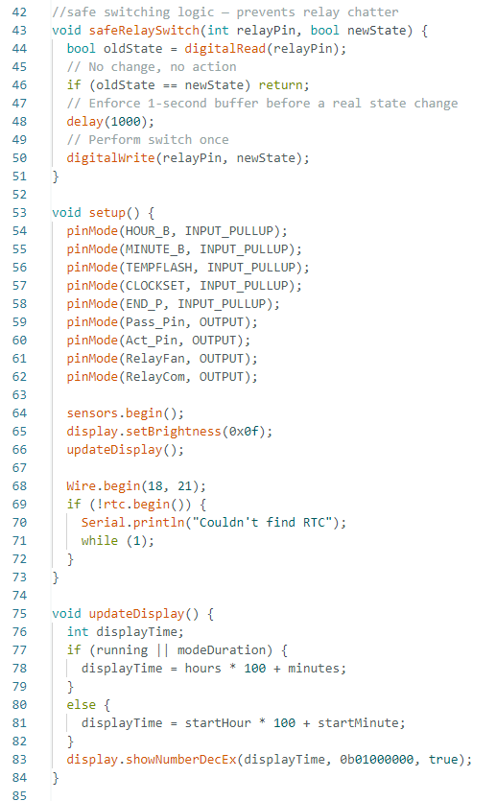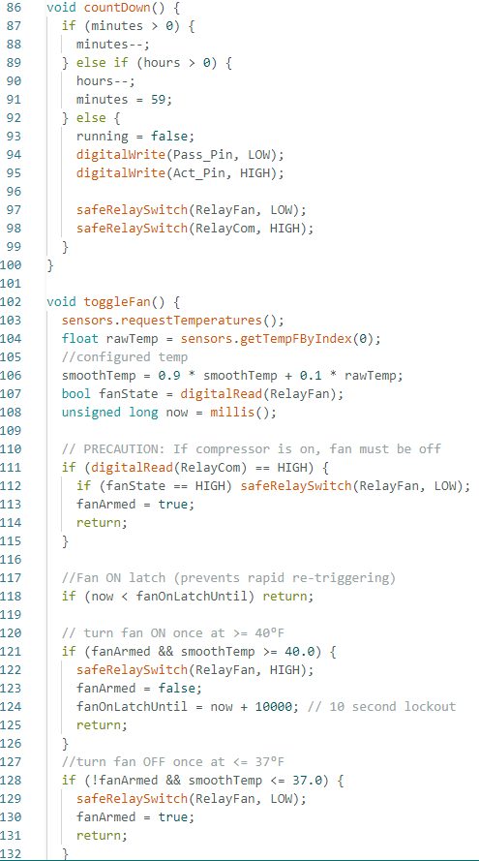

# 

# Appendix D: Excerpts from Datasheets of Components

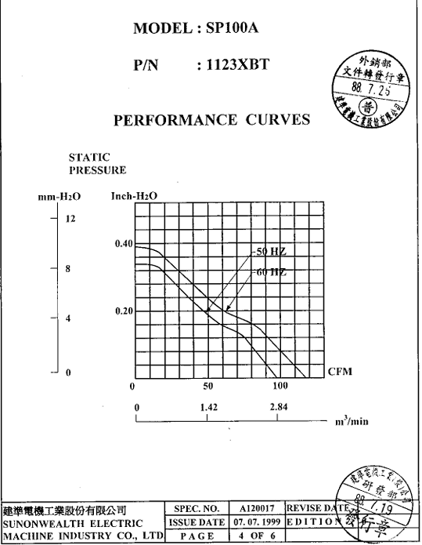

## Figure 42 - Fan Performance Sheet

# Appendix E: Customer Needs Survey

### Table 12 - Customer Needs Survey

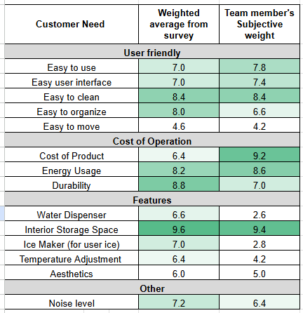

# Appendix F: Power and Temperature Data Logger Data and Plots

### Table 13 - Energy Calculation Summary Table for Energy Analysis

| Power averages: |  |  |
| --- | --- | --- |
| Average active power (MAX SETTING) | 48.21276 | W |
|  |  |  |
| Energy Sums: |  |  |
| 12/02/25 Passive period | 28.21493 | Wh |
| 12/05/25 Passive Period | 33.20938 | Wh |
| 12/07/25 3/4 Setting 3 Hour | 80.7002 | Wh |
| 12/04/25 Post Passive Peak | 238.5218 | Wh |
| 12/02/25 Post Passive Peak | 118.0245 | Wh |
| 11/28/25 Initial Peak | 181.7412 | Wh |
|  |  |  |
| MAX SETTING |  |  |
| Daily Energy consumption w/o retrofit | 144.6383 | Wh |
| Annual Energy cosumption w/o retrofit | 37.6 | kWh |
|  |  |  |
| 3/4 SETTING |  |  |
| Annual Energy consumption w/o retrofit | 21.0 | kWh |
|  |  |  |
| Additional Cost to Freeze |  |  |
| Based on 12/04/25 | AFTER PASSIVE | |
| Duration (15:30-20:00) | 4.5 | hr |
| Regular energy usage (MAX SETTING) | 216.9574 | Wh |
| Actual energy usage | 238.5218 | Wh |
| Difference | 21.56441 | Wh |
|  |  |  |
| Based on 12/02/25 | AFTER PASSIVE | |
| Duration (15:05-17:05) | 2 | hr |
| Regular energy usage (MAX SETTING) | 96.42552 | Wh |
| Actual energy usage | 118.0245 | Wh |
| Difference | 21.59901 | Wh |
|  |  |  |
| Based on 11/28/25 | INITIAL |  |
| Duration (16:30-20:00) | 3.5 | hr |
| Regular energy usage (MAX SETTING) | 168.7447 | Wh |
| Actual energy usage | 181.7412 | Wh |
| Difference | 12.99657 | Wh |

| Duration of Passive Cycle | 3 | hrs |
| --- | --- | --- |
| Daily Additional Energy to Freeze | 21.6 | Wh |
| Annual Additional Energy to Freeze | 5.6 | kWh |
| Average Passive Period Energy | 30.7 | Wh |
| Annual Passive Energy Consumption | 8.0 | kWh |
|  |  |  |
| Comparison to MAX SETTING |  |  |
| Annual Energy savings (PEAK) | 29.6 | kWh |
| Annual Cost Savings | 12.93386 | $ |
|  |  |  |
| Comparison to 3/4 SETTING | 13.0 | kWh |
| Annual Cost Savings | 4.289436 | $ |
|  |  |  |
| Energy cost during peak | 0.52 | $/kWh |
| Energy cost during off Peak | 0.44 | $/kWh |
|  |  |  |
|  |  |  |
| 12/5 percentage of time above 41 degrees | 21% |  |
|  |  |  |
| Fan Average Power | 22.60931 |  |
| IDLE power consumption average | 0.803462 |  |

## Figure 43: Temperature and Power plot from 11/29 to 12/07

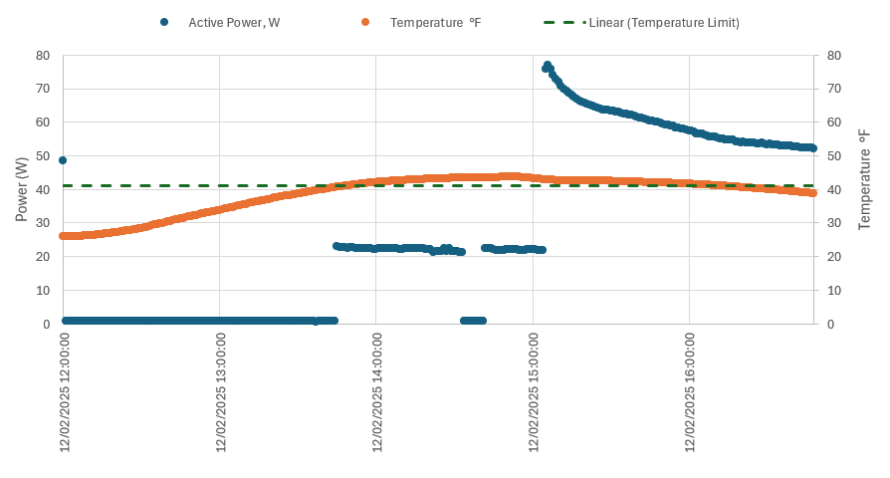

## Figure 44 - Temperature and Power Plot for December 2nd, 2025